MONGODB ASSIGNMENT

- Install MangoDB databse server.

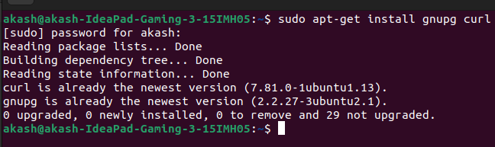
- Create a directory/folder to store MongoDB datafiles.
- Set neccessay path environment variable .
Startup MongoDB datase.
- Connect to MongoDB database through the MongoDB shell command line.
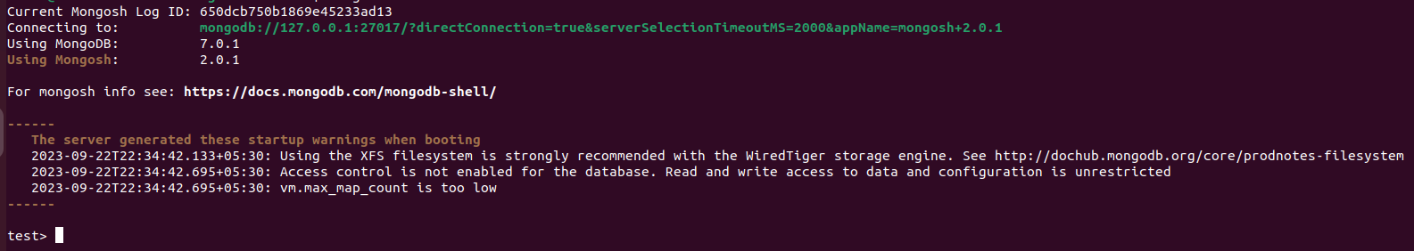
- View list of available database.

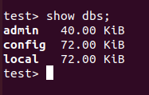

- Create a new databse named cdac and connect to it.

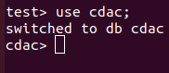

- View list of availabe collection in cdac database.

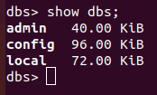

- Create a new collection by the name of LIBRARY.

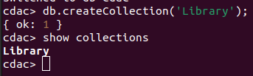

- Insert the following doccument in the LIBRARY collection :-
tiltle : ‘MangoDB Programming’
author : ‘Sameer’ likes : 100.

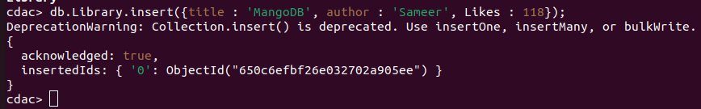

11. View the resently inserted document and note _id field.

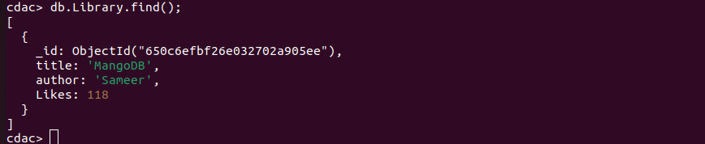
12. Insert another document in LIBRARY Collection as Follows :-
title : ‘MySQL Programming’,
authors : [‘Jack’,’Jill’], Likes : 200.

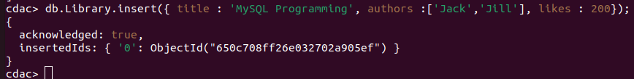
13. View the inserting doccuments.

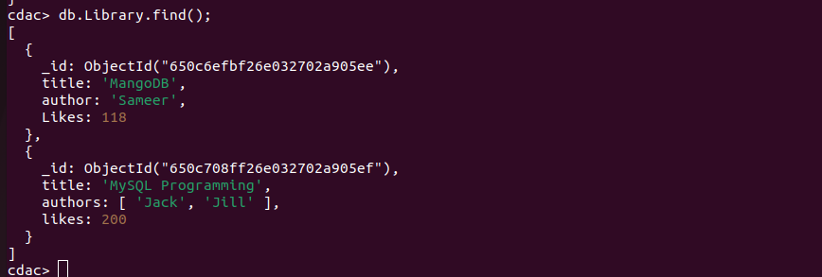

14. View only first inserted doccument.

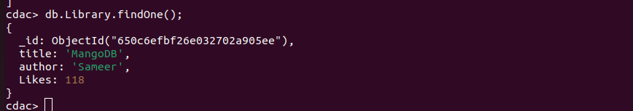

15. View the documents using Pritty method.

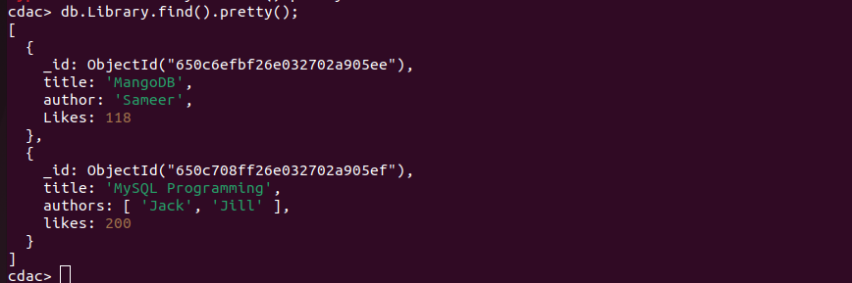

17. Delete all documents that have 100 likes.

18. Drop LIBRARY collection.

Ans : db.Library.drop();

19. Drop the CDAC database.
20. Exit from MongoDB shell.
21. Stop MongoDB server.
