Assigment no 1

1. man

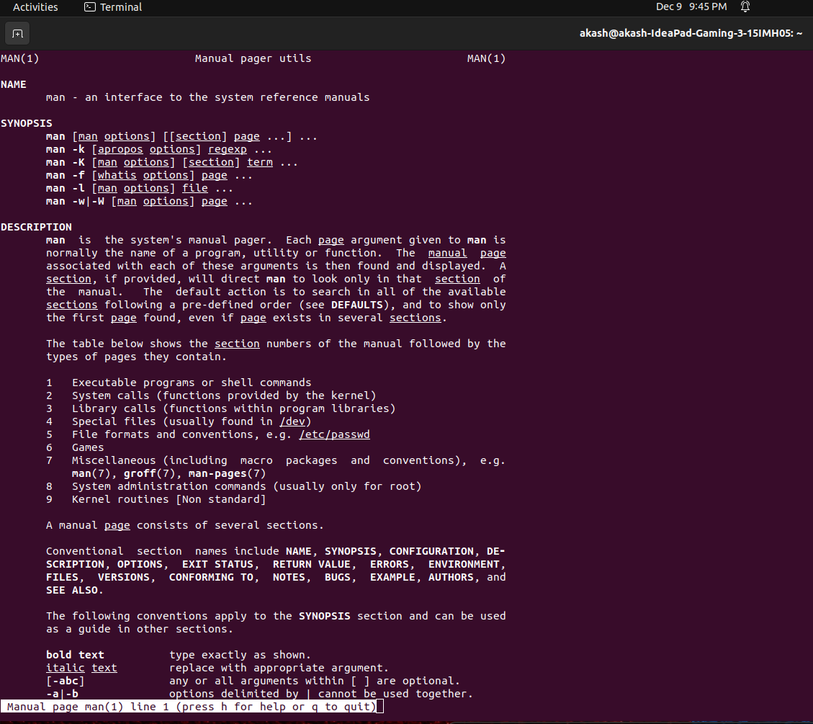
2. uname
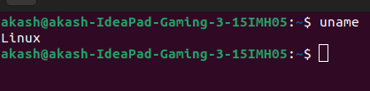

3. pwd

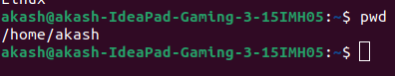

4. hostname

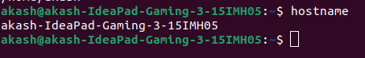

5. date

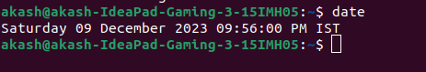

6. cal

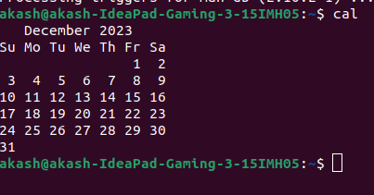

7. ls, dir

8. cat > Demo.txt

9. cat >> Demo.txt

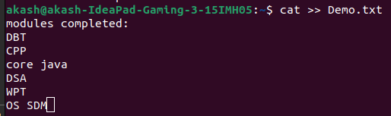

10. cp Demo.txt Demo

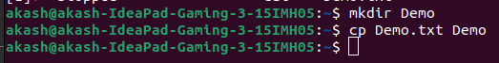


11. mv Copy Demo

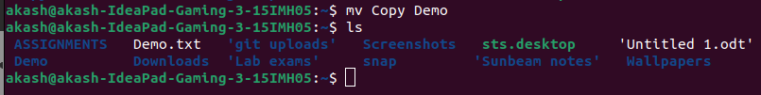
12. mv Demo.txt Demo1.txt

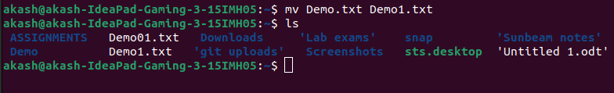

13. tac Demo1.txt
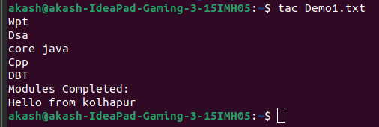

14. wc Demo1.txt
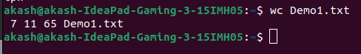

15. mkdir Practice
16. cd Practice
(Both Commands in Single SC)
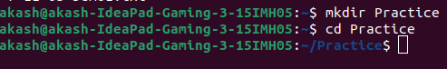

17. rm -r Practice
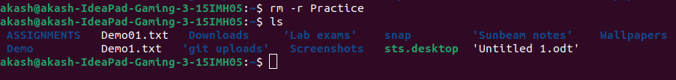

19. touch file1.txt file2.jpg file3.pdf file4.odt
touch -m file1.txt
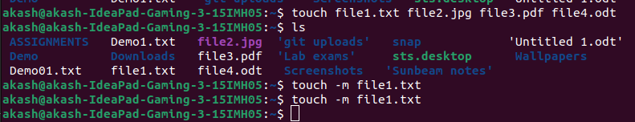

20. sort Demo1.txt
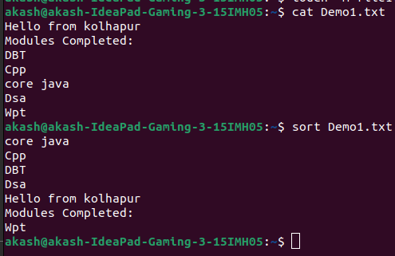

21. uniq file1.txt
OR
sort -u file1.txt

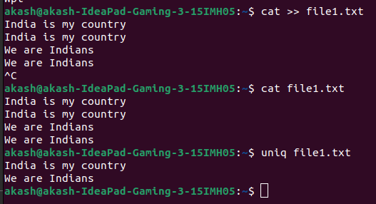

22. head -n 5 Demo1.txt

