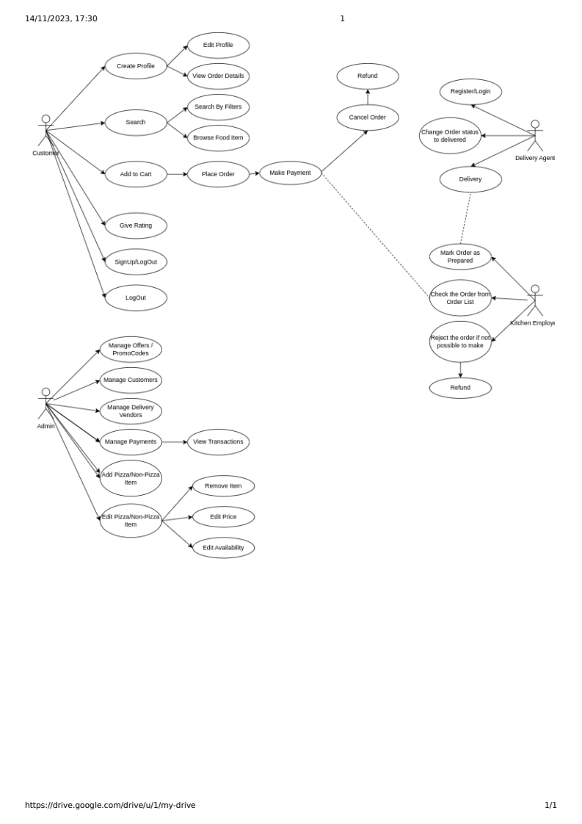
Use Case Diagram:

Four main use cases are identified as
1) Ordering : involves Customer
2) Order Processing : Involves Kitchen Employee
3) Delivery: involves Delivery Agents
4) Administrator: involves Admin

1)Ordering :
The first use case involves potential customers to go through the various types of Pizza and non Pizza items available at PizzaHut cafe. Cusomer can add the pizza in the cart, can increase the quantity, can add the non Pizza Items such as drinnks/salads/dips/fries and can increase the quantity. Customer will require to provide his/her name,address and phone number. Customer can also order in advance for upto two weeks by providing time and date with order item details.
2)Order Processing:
When an order has been confirmed by the customer then order processing begins. Throughout the order processing the order status will be changed and customer will be notified. New orders will show up in the list of Orders for employees in the kitchen. Kitchen Employees have to check if the can prepare perticular order or not. When kitchen employee accepts the order the order status will change and customer can view the status of the order.
3) Delivery:
After Order is prepared the delivery agent will be notified and he/she will take over the order. After successful delivery of the order the order status will again get change to complete.
4) Administration:
Pizza and non-Pizza items can be ordered by customers, the list is made available on the portal by administrators. Administrators can add, delete, edit Pizza and non-Pizza items. Also Administrators maintains logs of previous order details.

Functional Requirements:
Customer:
1) Customer can able to login/SignUp.
2) Customer can able to edit profile.
3) Customer can able to search by filters or directly by name.
4)can view the available pizza and non-Pizza Items.
5)can choose the pizza and add into cart.
6)can increase or decrease the quantity of the selected pizza and non pizza iteam.
7) can make payment.
8) can view the order details.
9) can cancel the order.
10) can give Rating.
11)can logout.

Administrator:
1) can login and logout
2) can Manage customers : view customers, delete/ban customers, view orders by customers.
3) can manage delivery vendors : remove vendor, view vendor, view deliveries by vendors.
4) can manage payments : view payment details
5) can add pizza / non-pizza items.
6) can edit pizza / non pizza items : remove item, edit item, edit availability.

Kitchen Employee:
1) Can check for the orders.
2) Can accept order.
3) Can reject order.
4) Can make the order status as prepared.

Delivery Vendor:
1) Can register/Login.
2) Can check orders to be delivered.
3) change the status of order as delivered.

Non Functional Requirements:
1) An automatic welcome mail should be dropped to the customer after successful registration.
2)A automatic Thankyou mail should get dropped to the customer after successful Payment and delivery of an item.
3) An invoice should get generated after syuccessful payment.

UI Design:
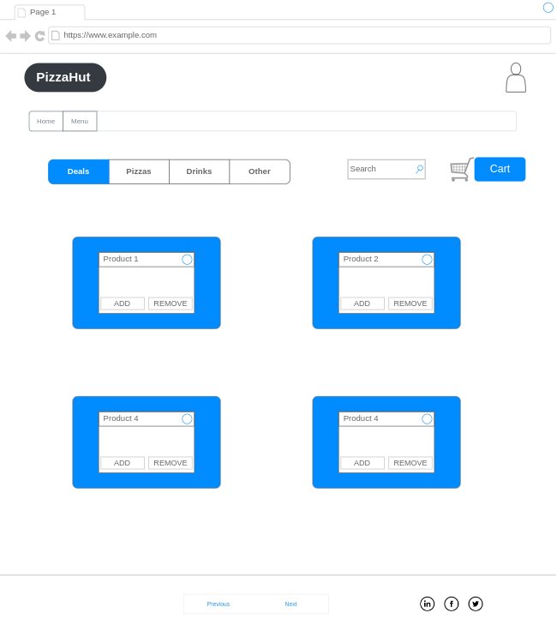
Home Page:

Login Page:
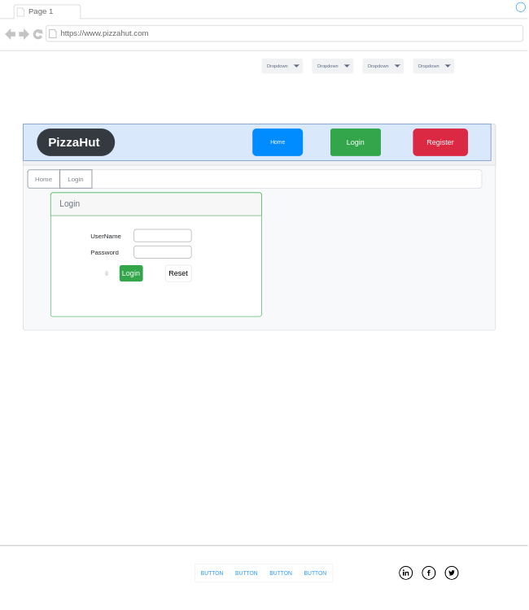

Register:

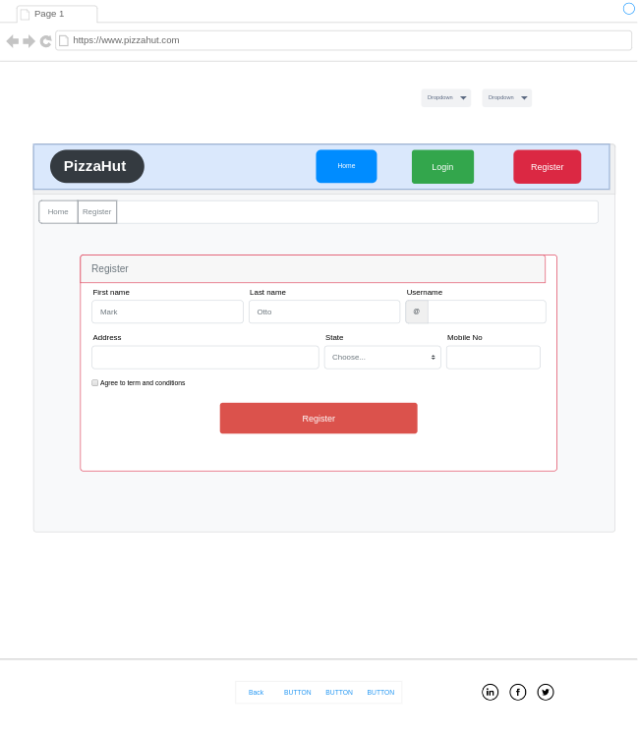

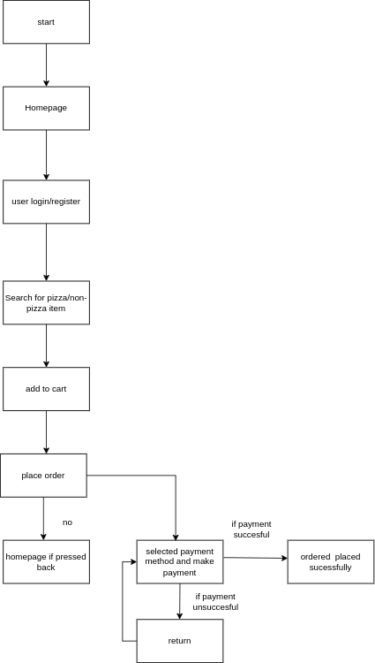
Customer:

Admin Page :
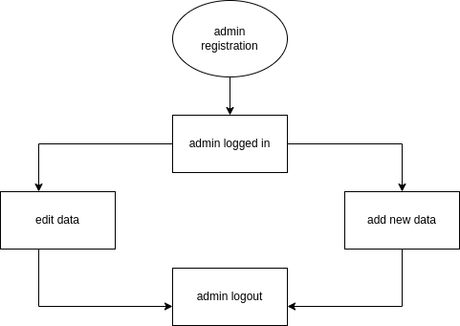
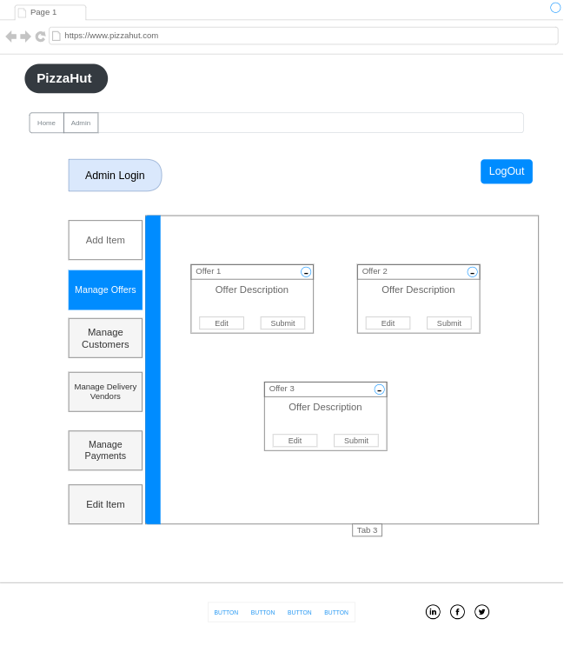

Kitchen Employee: 3

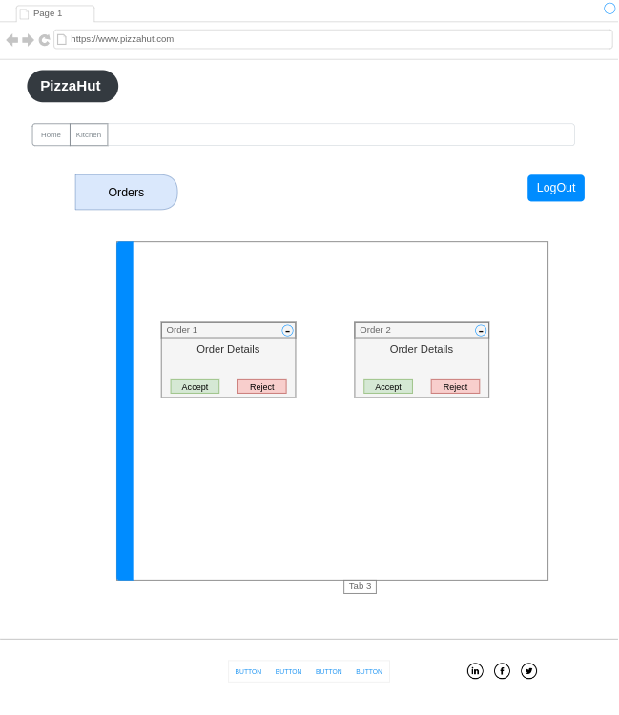
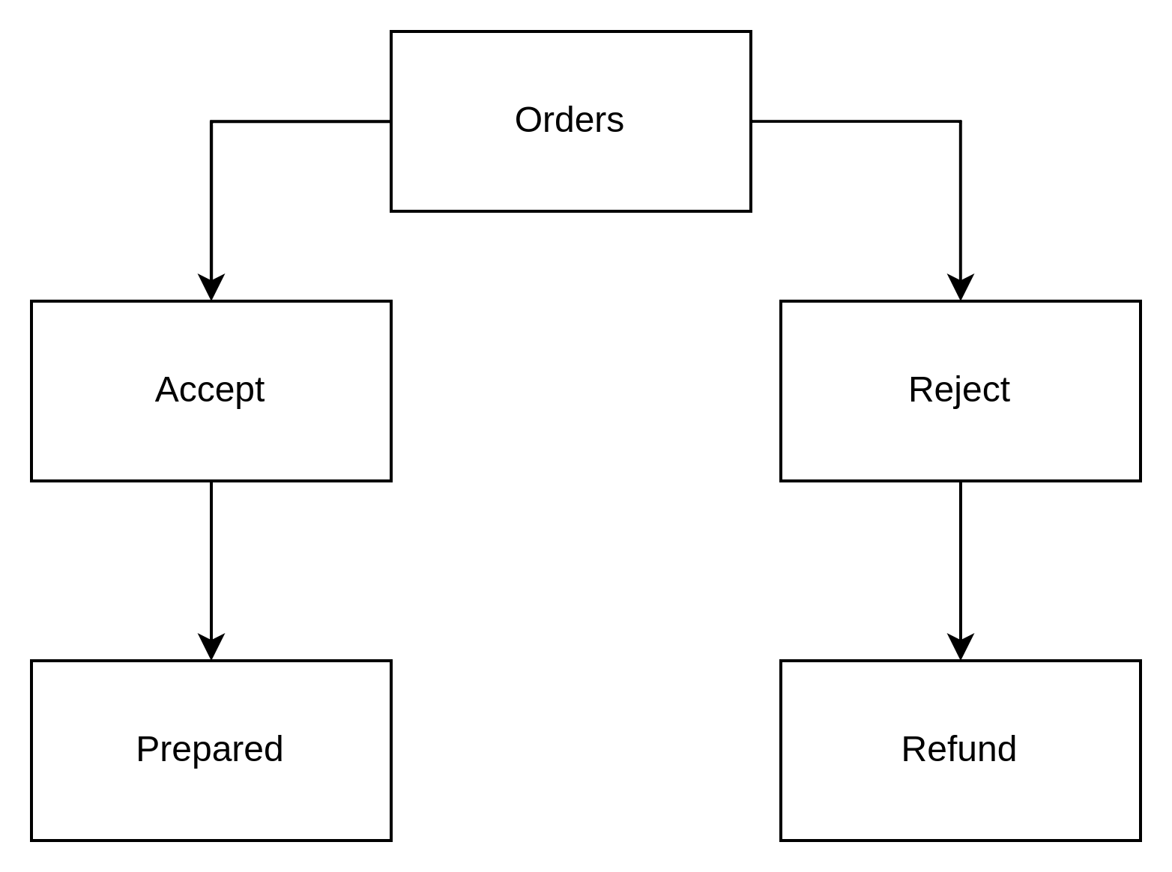
Delivery Agent

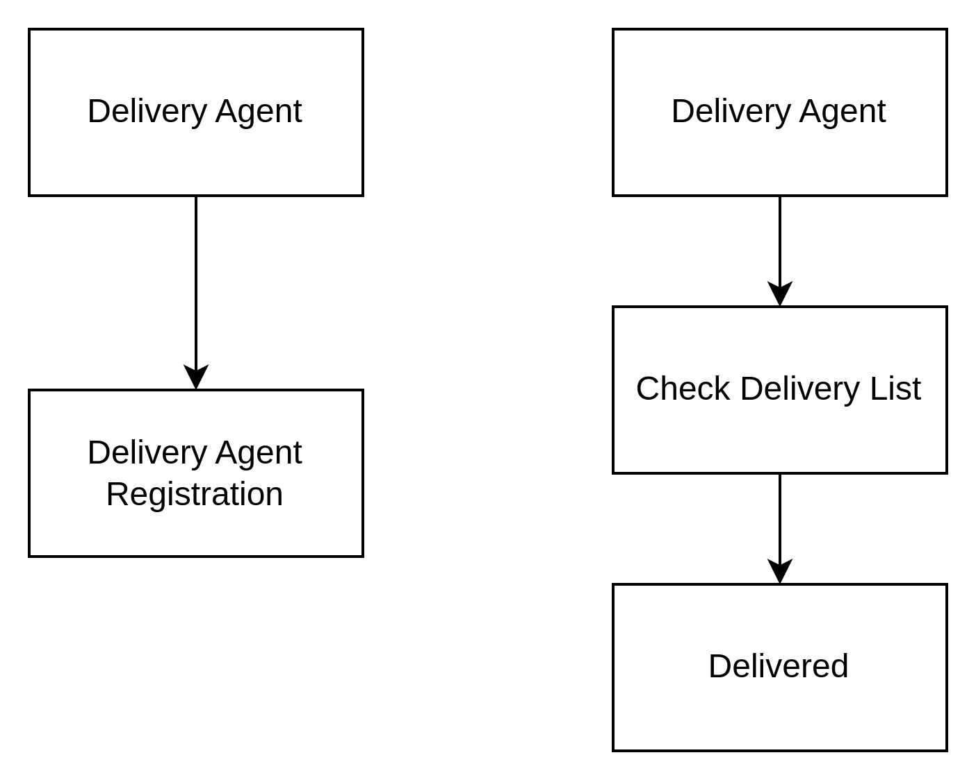

DataBase Design:
