Assignment-7

Q1. Write a query thet counts all the orders for october 3.

Q2. Write the query that counts the number of the different non null city values in the customers table.
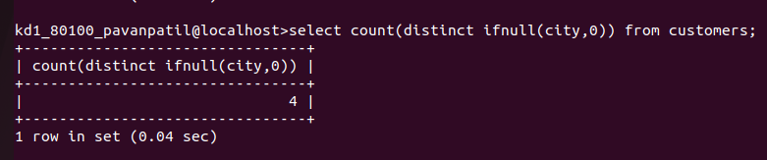
Q3. Write a query to select the each customers smallest order.
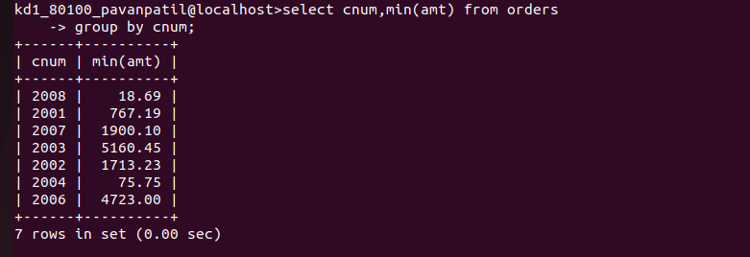
Q4. Write a query that selects the first customer, in alphabetical order, whose name begins with G.



Q5. Write a query that selects the highest rating in esch city.
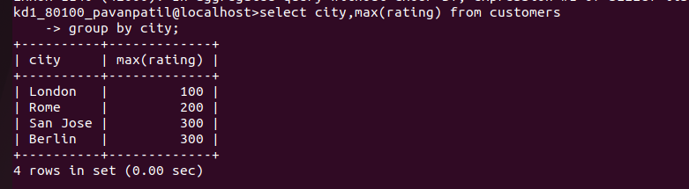
Q6. Write a query that counts the number of salespeople registering orders for each day.(If a sales person has more than one order on a geivenday, he or she should counted only once.)
