Assignment-1

Q1. Creating the following tables with the given structures and insert sample data as specified:

A) SALESPEOPLE
snum int(4),
sname varchar(10)
city varchar (10)
comm float(3,2)
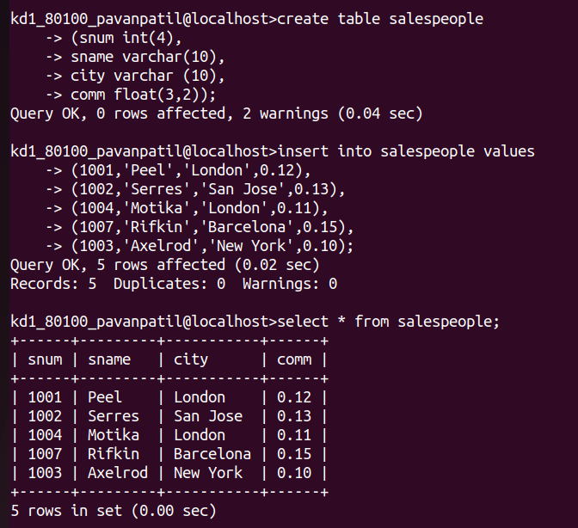

B) CUSTOMERS
cnum int(4)
cname varchar(10)
city varchar(10)
rating int(4)
snum int(4)

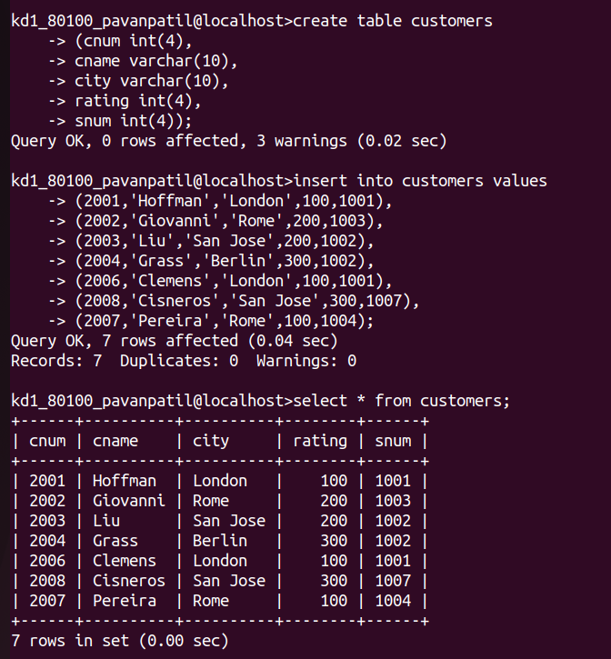

C) ORDERS:
onum int(4)
amt float(7,2)
odate date,
cnum int(4)
snum int(4)

