MongoDB Assignment

Q1. Install MongoDB database server
Q2. Create a directory/folder to store MongoDB datafiles
Q3. Set necessary path environment variable
Q4. Startup MongoDB database

Q5. Connect to MongoDB database through the MongoDB shell command line interface.
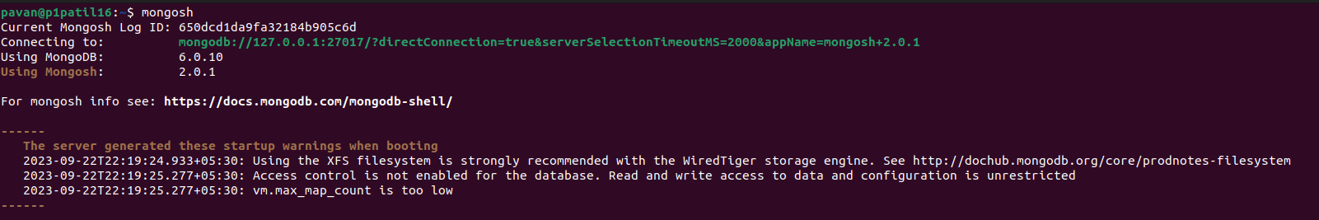
Q6. View list of available databases.
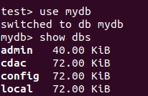

Q7. Create a new database named CDAC and connect to it.
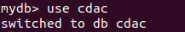

Q8. View list of available collections in CDAC database.
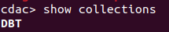

Q9. Create a new collection by the name of LIBRARY.
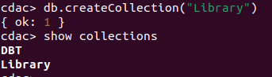

Q10. Insert the following document in the LIBRARY collection:-
title:'MongoDB programming', author:'Sameer', likes:100
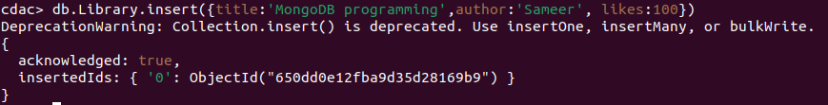

Q11. View the recently inserted document and note the _id field.
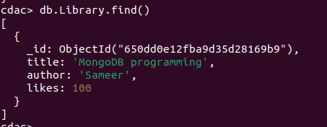

Q12. Insert another document in the LIBRARY collection as follows:-
title:'MySQL programming', authors:['Jack','Jill'], likes:200
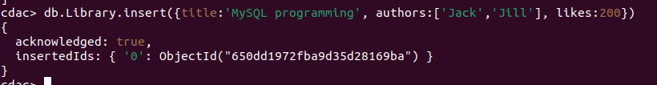
Q13. View the inserted documents.
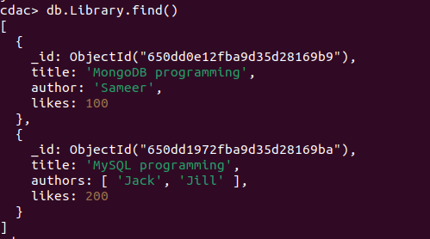

Q14. View only the first inserted document

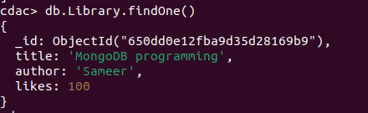

Q15.View the documents using the pretty() method
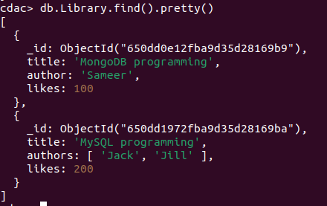

Q16. Update the document where author name = Sameer and change it to Sameer Dehadrai
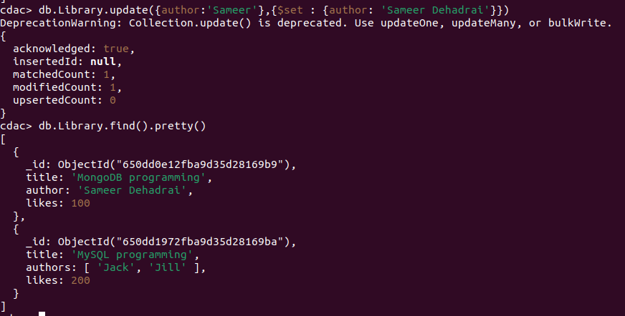
Q17. Delete all documents that have 100 likes
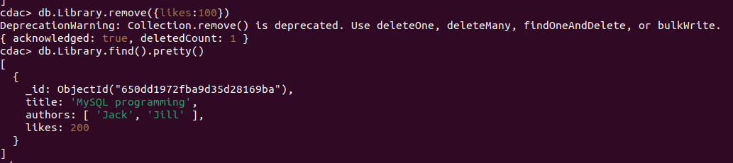

Q18. Drop the LIBRARY collection
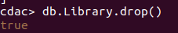

Q19. Drop the CDAC database
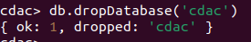

Q20. Exit from MongoDB shell
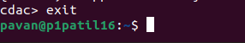

Q21. Stop MongoDB server
