Assignment-6

Q1. Write two diff queries that would produce all orders taken on october 3rd or 4th,1990

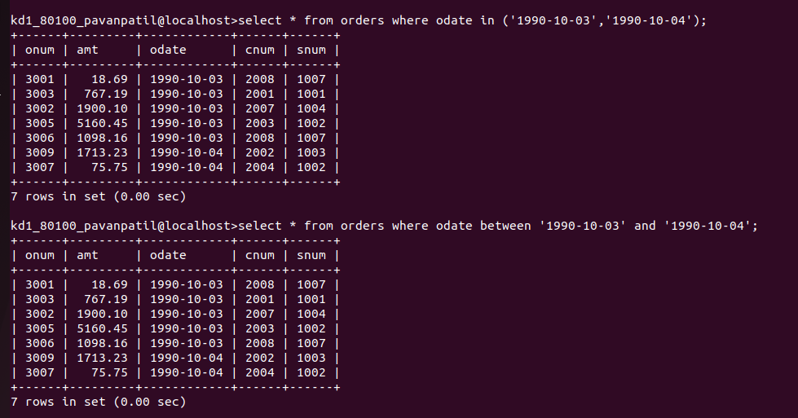
Q2. Write a query that selects all of the customers serviced by peel or motika.
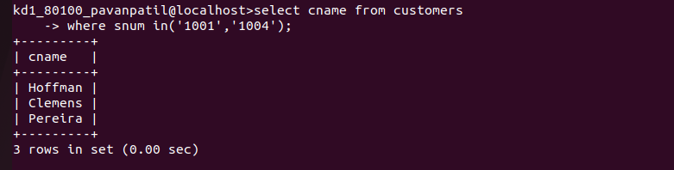

Q3. Write a query that will produce all the customers whose names begin with a letter from ‘A’ to ‘G’.
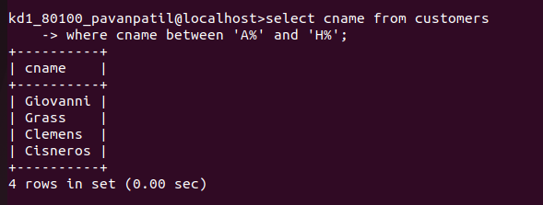
Q4. Write a query that selects all customers whose names begin with the letter ‘c’.
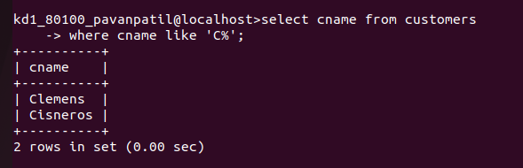
Q5. Write a query that selects all orders except those with zeroes or NULLs in the amt field.
