Assignment No:4
(Linux Commands)
1.
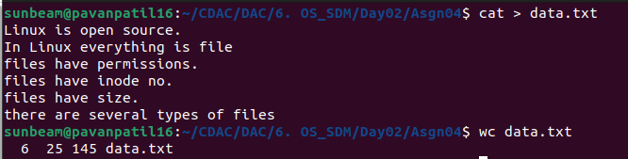
2.
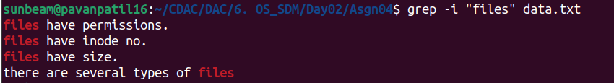
3.
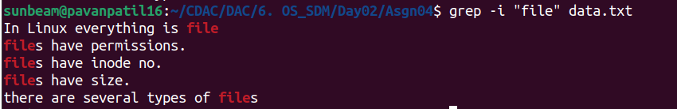
4.
5.
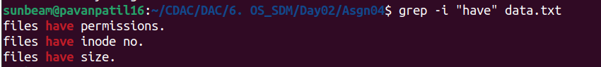
6.
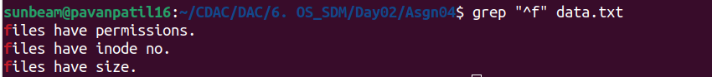

7.
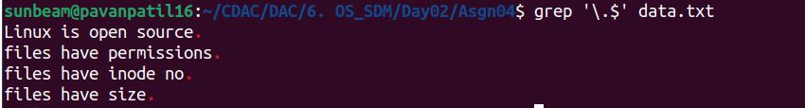
8.
9.
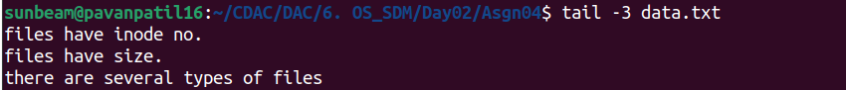
10.
