Assignment No:2
(Linux Commands)

1.
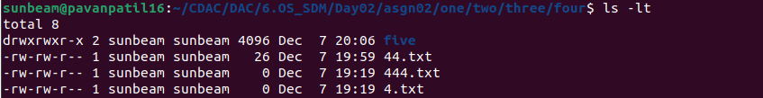
2.
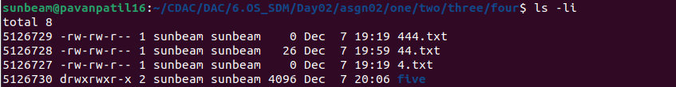
3.
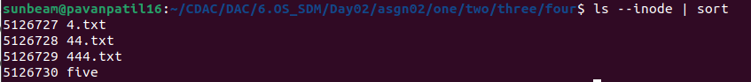
4.
5.
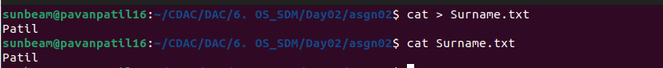
5.1 & 5.2


6.

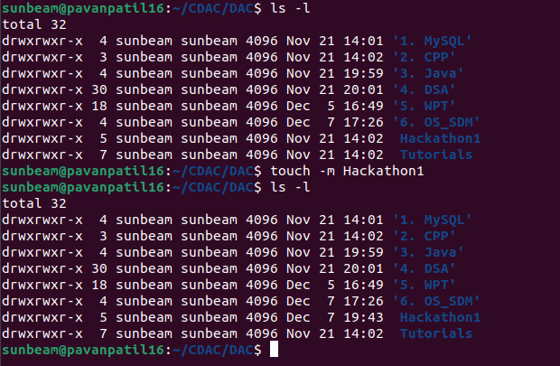
7.
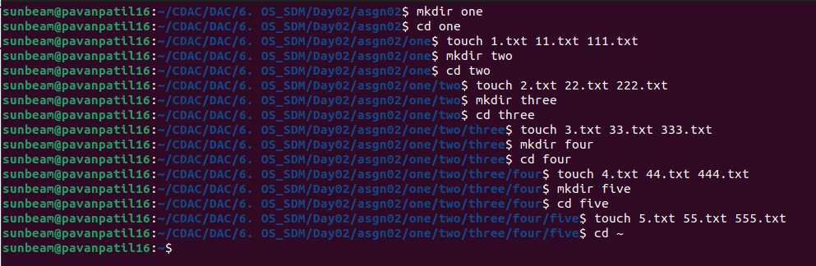
8.
8.1

8.2
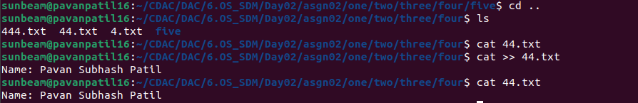
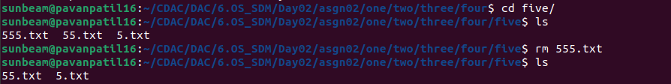
8.3

8.4
8.5
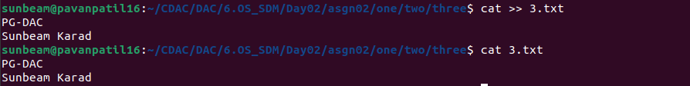
8.6
8.7
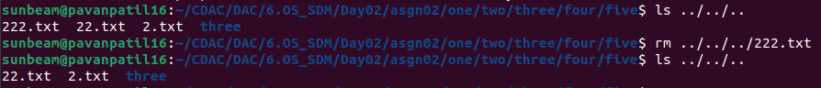
8.8
8.9

8.10
8.11
8.12
9.
