Assignment No:1
(Linux Commands)
1. man
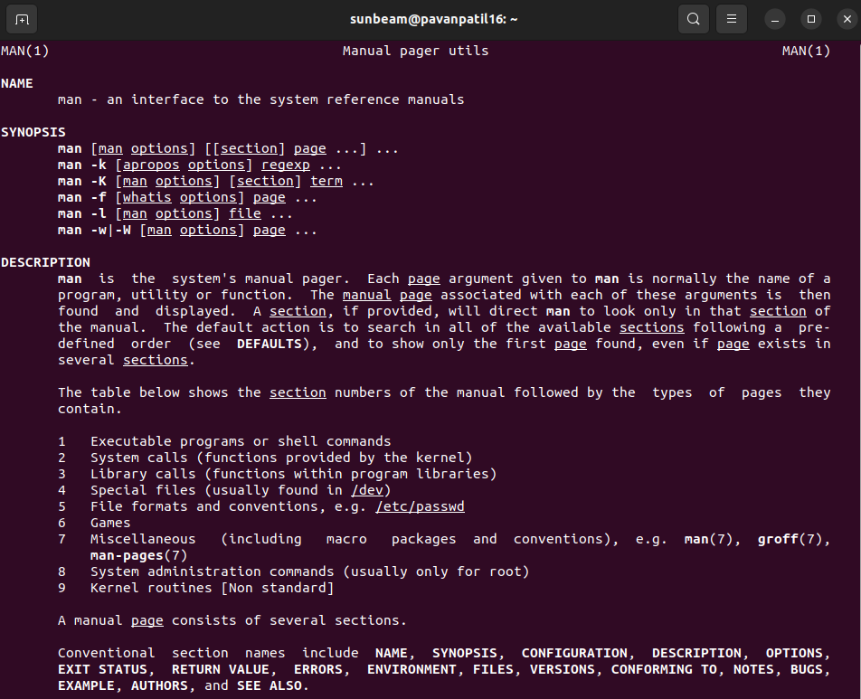
2. uname
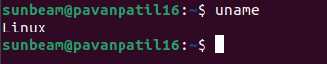

3. pwd
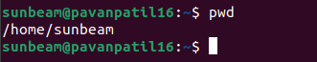

4. hostname
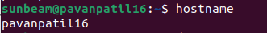

5. date
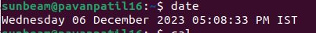

6. cal
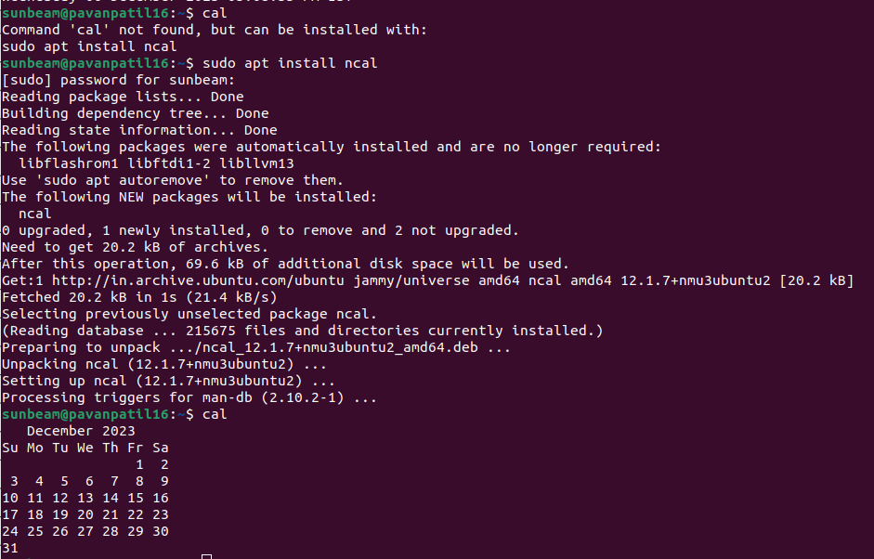
7. ls, dir
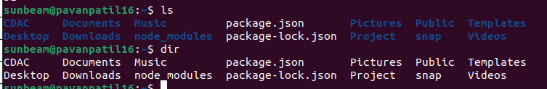
8. cat > Demo.txt
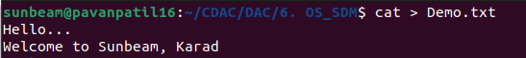

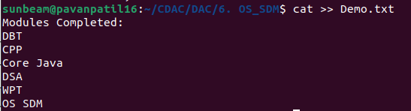
9. cat >> Demo.txt

10. cp Demo.txt Demo
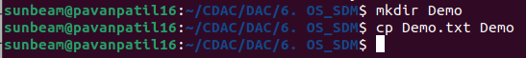

cp -r Demo Copy
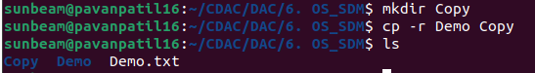

11. mv Copy Demo
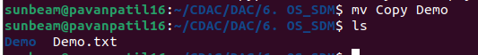

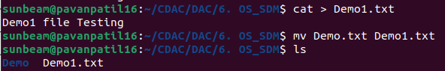
12. mv Demo.txt Demo1.txt

13. tac Demo1.txt
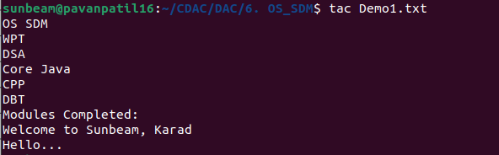

rev Demo1.txt
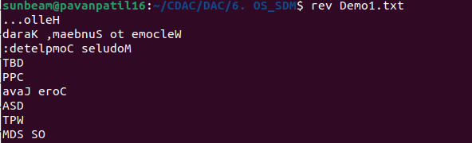
14. wc Demo1.txt

15. mkdir Practice
16. cd Practice
(Both Commands in Single SC)
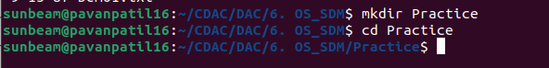
17. rm -r Practice
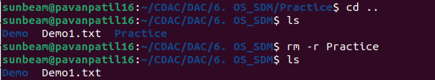
rm Demo.txt
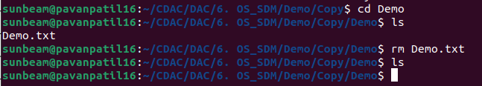
18. rmdir Demo
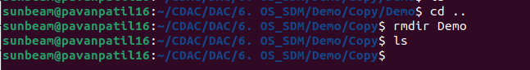

19. touch file1.txt file2.jpg file3.pdf file4.odt
touch -m file1.txt
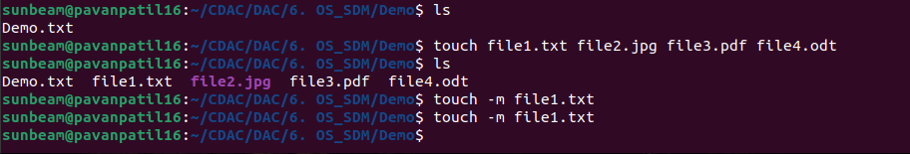
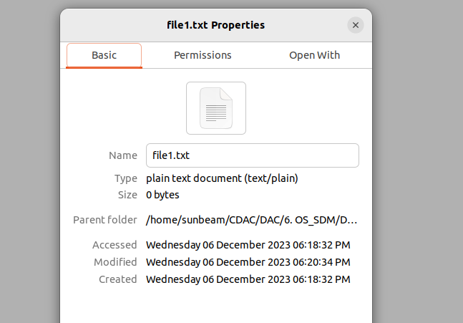

20. sort Demo1.txt
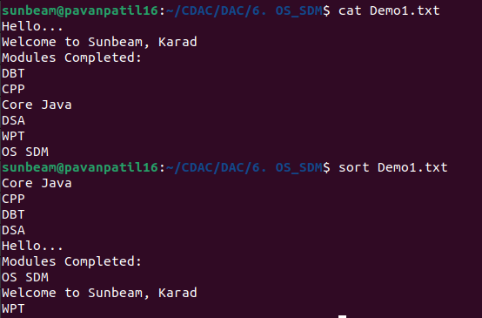

21. uniq file1.txt
OR
sort -u file1.txt
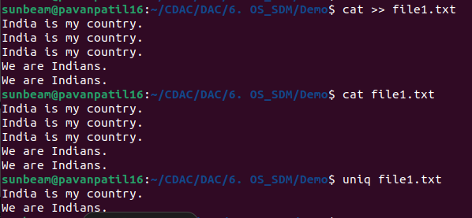
22. head -n 5 Demo1.txt
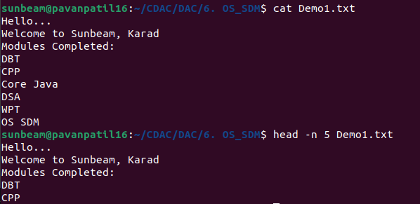

23. tail -n 3 Demo1.txt

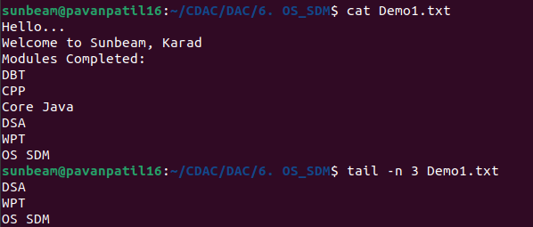
24. factor 25
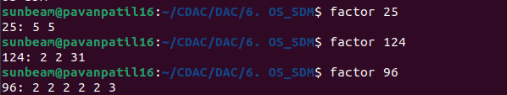
25. alias
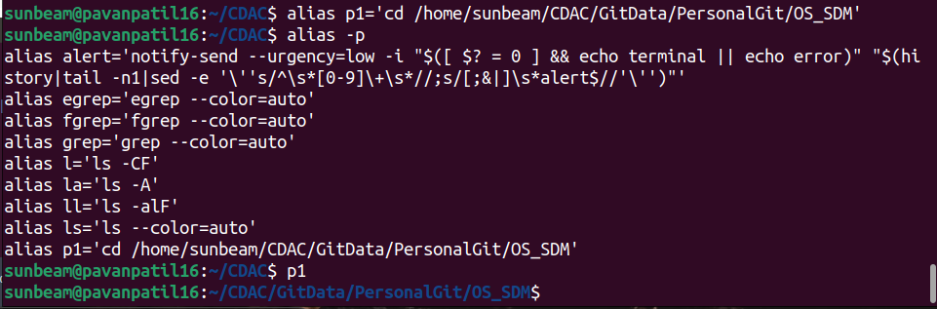
26. unalias
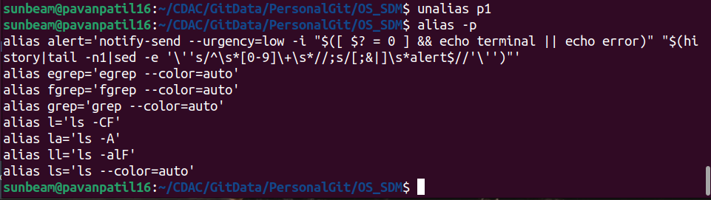

27.echo -e "welcome to CDAC \nSunbeam \tKarad"
28. ps
AND
ps -e

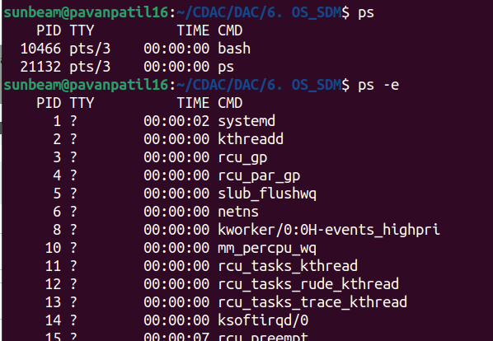
29. kill 7238

30. env
