Q1) Write a select command that produces the order number, amout, and date for all rows in the orders table.
SQL Assignment 4

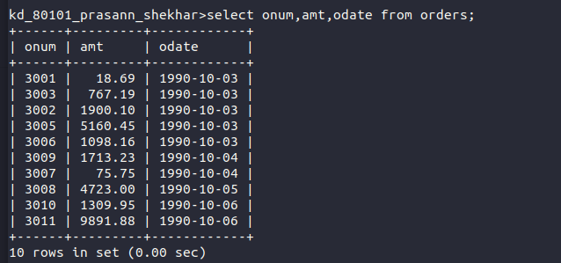

Q.2) Write a query that produces all rows from the customers table for which the salesperson’s number is 1001

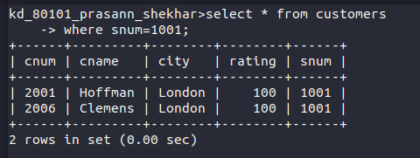
Q.3) Write a query that displays the salespeople table with columns in the following order city, sname, snum, comm.

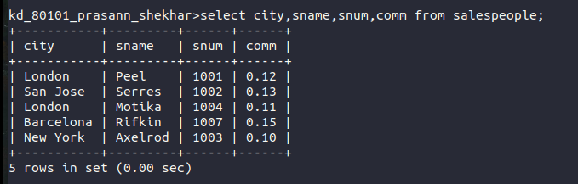

Q.4) Write a select command that produces the rating followed by the name of each customers in San jose.

