SQL Assignment 5

Q.1) Write a query that will give you all orders for more than RS 1000.

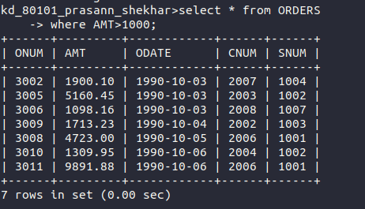

Q.2) Write a query that will give you the names and cities of all salespeople in london with commission above .10

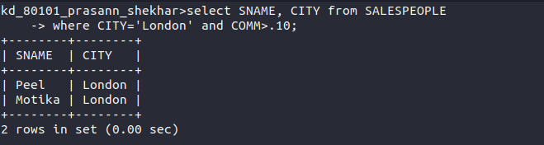

Q.3) Write a query on the customers table whose output will exclude all customers with rating <=100,unless they are located in rome.
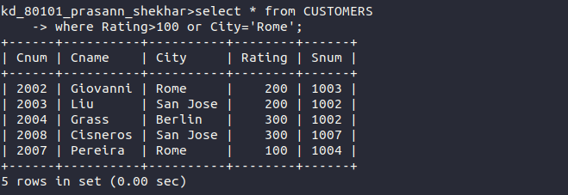

Q.4) What will be the output from the following query.

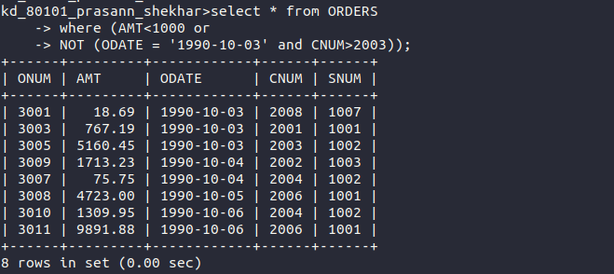

Q.5) What will be the output from the following query.

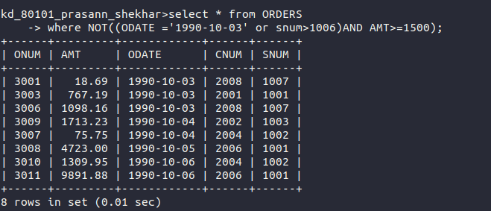

Q.6) What is a simpler way to write this query

