Q . Create the following tables with the given strutures and insert sample data as specified:
SQL ASGN-1

A)SALESPEOPLE

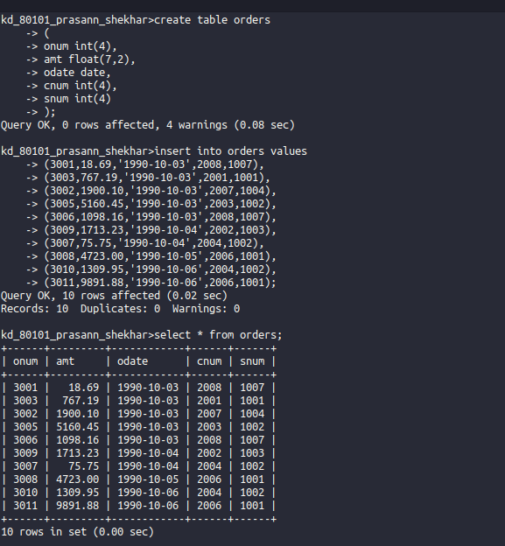

B) CUTOMERS:

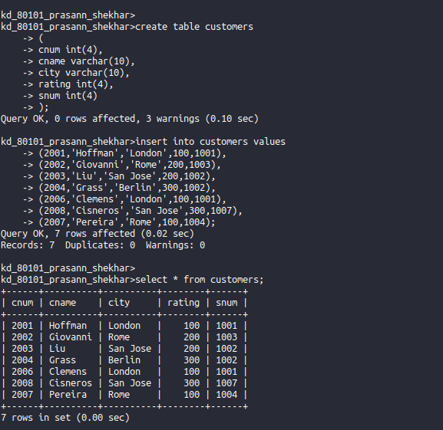

C) SALESPEOPLE:
