ASSIGNMENT NO 6

Q1 WRITE TWO DIFFERENT QUERIES THAT WOULD PRODUCE ALL ORDERS TAKEN ON OCTOBER 3RD OR 4TH,1990.

- QUERY 1 :

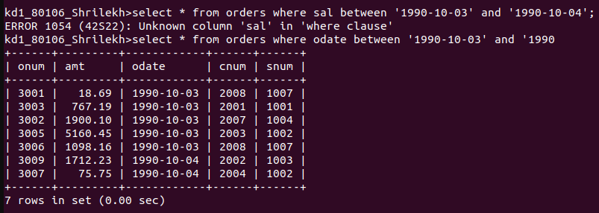

- QUERY 2

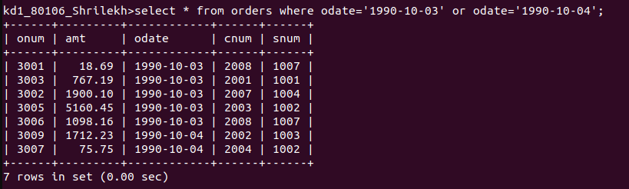
n

Q6.2)

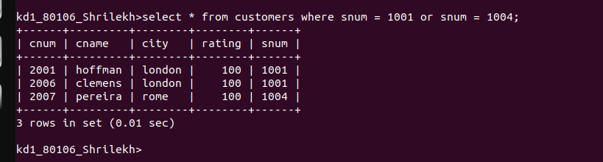

Q 6.3)

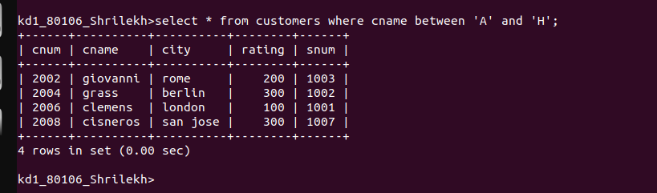

Q 6.4)

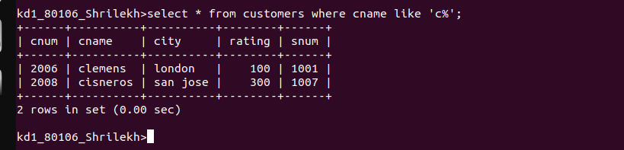

Q.6 .5

