ASSIGNMENT - 7

Q1 : WRITE A QUERY THAT COUNTS ALL ORDERS FOR OCT 3 .

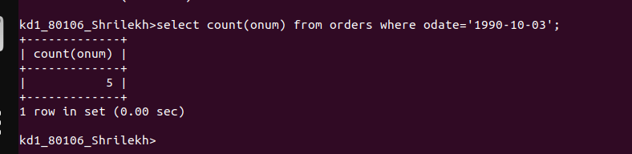
Q JYYURR,YU

Q2 : Write a query that counts the numbers of different non-NULL city values in the customers table.



Q 3 :Write a query that selects each customer’s smallest order.
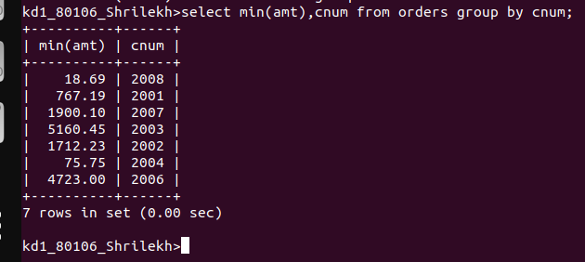
Q f

Q 4 : Write the query that selects the first customers in alphabetical order,whose name begins with G.

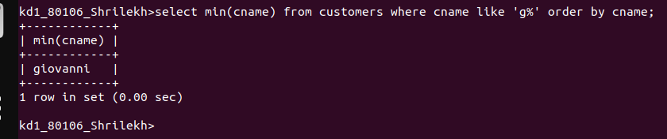

Q 5 : Write a query that selects the highest rating in each city.

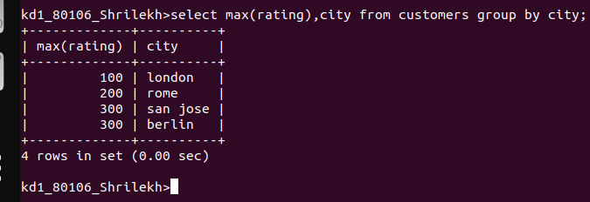

Q 6 Write a query that counts the number of salespeople registering orders for each day.

