ASSIGNMENT 9

Q 1 ) WRITE A QUERY THAT LISTS EACH ORDER NUMBER FOLLOWED BY THE NAME OF THE CUSTOMER WHO MADE THE ORDER.

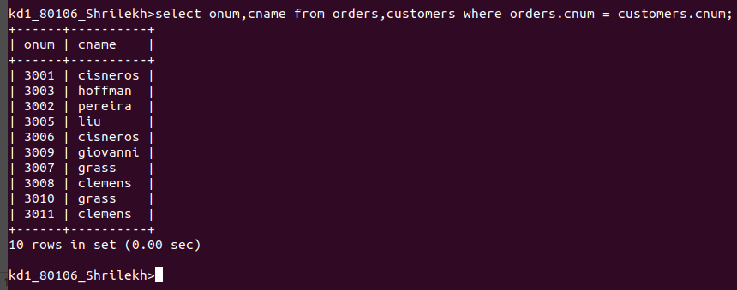
1

Q2 WRITE A QUERY THAT GIVES THE NAMES OF BOTH THE SALESPERSON AND THE CUSTOMER FOR EACH ORDER ALONE WITH THE ORDER NUMBER .

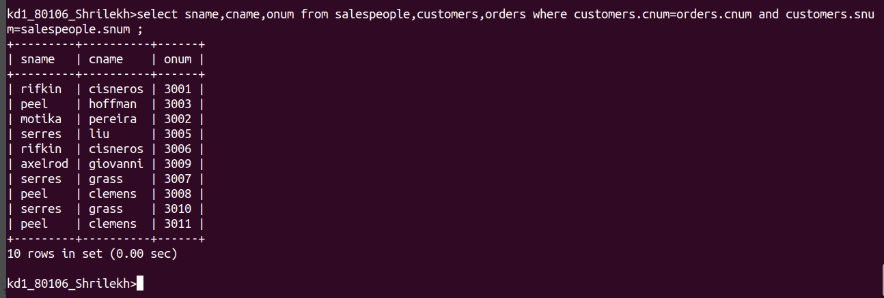
Q
Q 3

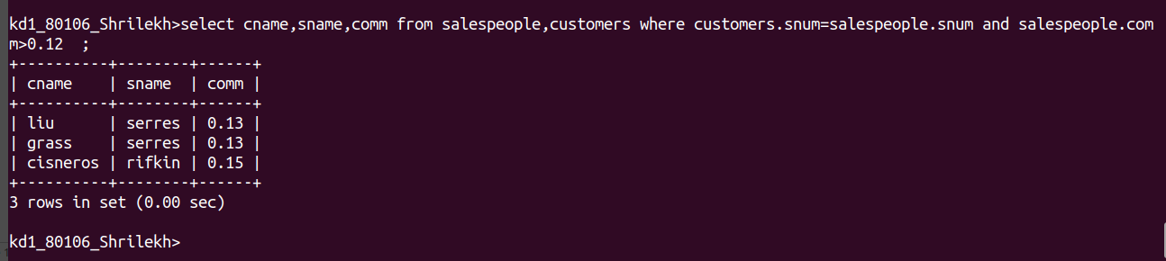

Q3) Write a query that produces all customers serviced by salespeople with a commission above 12%. Output the customer's name, the salesperson's name, and the salesperson's rate of commission.

Q 4) Write a query that calculates the amount of the salesperson's commission on each order by a customer with a rating above 100.

