SQL ASSIGNMENT 5

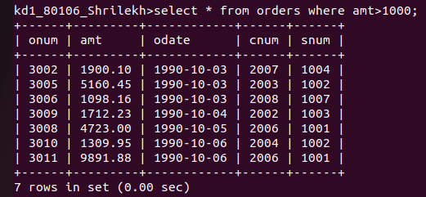
Q5.1

Q 5.2)
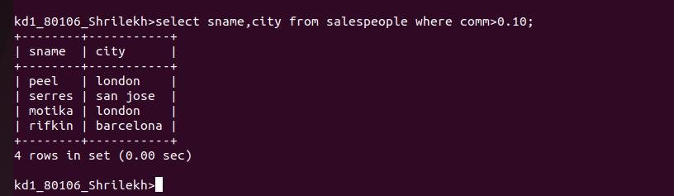

Q 5.3)

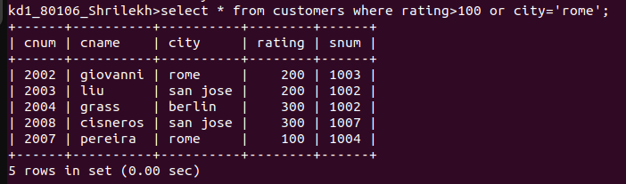

Q5.4) What will be the output from the following query,

Select * from Orders

where (amt < 1000 OR NOT (odate = '1990-10-03

AND cnum > 2003));

SOLN-

STEP 1 : BRACKETS( odate = '1990-10-03

AND cnum > 2003) and WILL GET HIGHEST PRIORITY
STEP 2 : OUTPUT OF WHICH WILL BE EVALUATED WITH NOT OPERATOR .
STEP 3 : OUTPUT OF (amt < 1000 ) SHALL BE EVALUATED WITH OR OPERATOR AGAINST OUTPUT OF STEP 2 .

Q5.5) What will be the output of the following query? Select from Orders

where NOT ((odate = '1990-10-03 OR snum

>1006) AND amt >= 1500);

SOLN-

STEP 1 : (odate = '1990-10-03 OR snum

>1006)
THIS BRACKET WILL BE EVALUATED WITH HIGHEST PRIORITY.
STEP2 : OUTPUT OF BRACKET SHALL BE EVALUATED WITH AND OPERATOR AGAINST amt >= 1500 .
STEP 3 : OUTPUT OF STEP 1 AND STEP 2 IS NEGATED BY NOT OPERATOR .

Q5.6)
