ASSIGNMENT 12

Q1. Write a query that selects all customers whose ratings are equal
to or greater than ANY of Serres’.

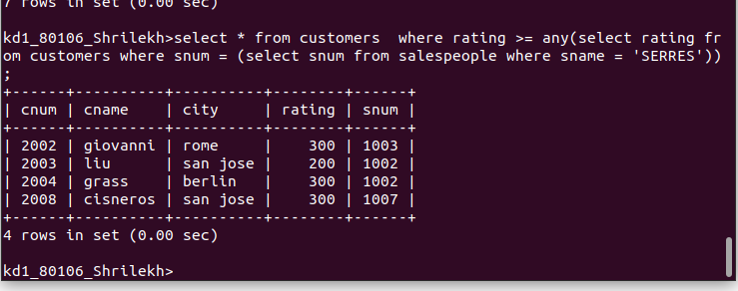
1

Q2. Write a query using ANY or ALL that will find all salespeople who have no customers located in their city.
Ans.

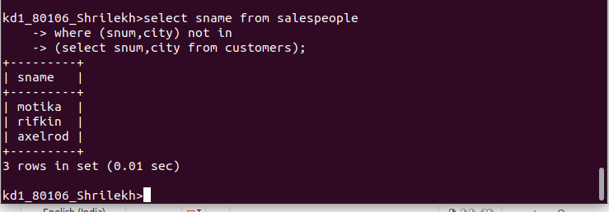

Q3. Write a query that selects all orders for amounts greater than any for the customers in London.

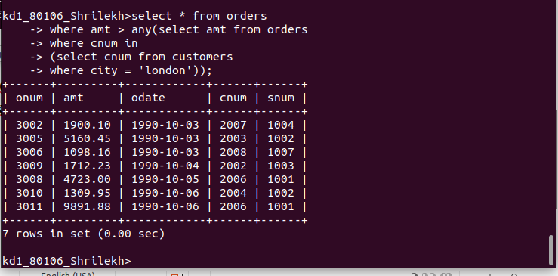

Q4. Write the above query using MIN or MAX.

