ASSIGNMET 14

- Write a command that puts the following values, their given order, into the salespeople table: City San Jose, name - Blanco, comm - NULL, cnum 1100.

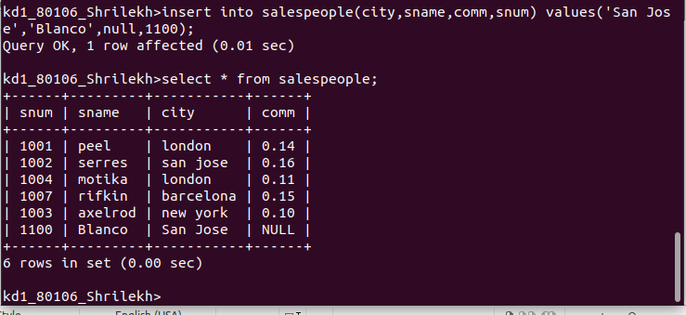

2.Write a command that removes all orders from Customer “Clemens” from the Orders table.
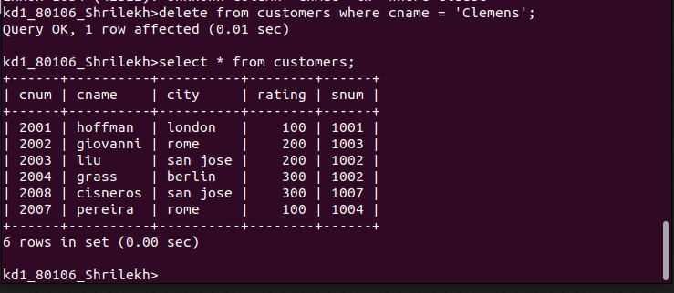
1

3.Write a command that increases the rating of all customers in rome by 100.

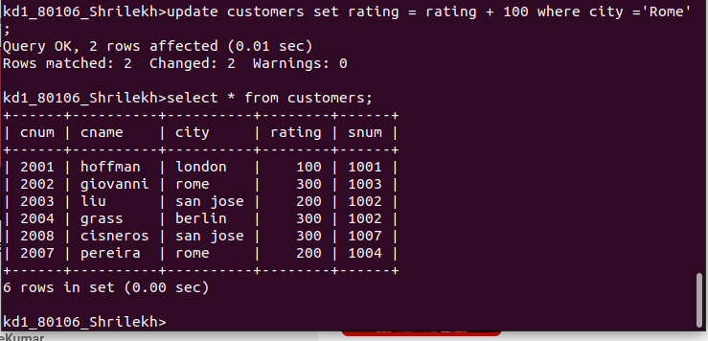

4)Salesperson Serres has left the company. Assign her customers to Motika.

