ASSIGNMENT 15

1)Assume there is a table called multicust all of the same column definitions as salespeople.Write a command that inserts all salespeople with more than one customer into this table.
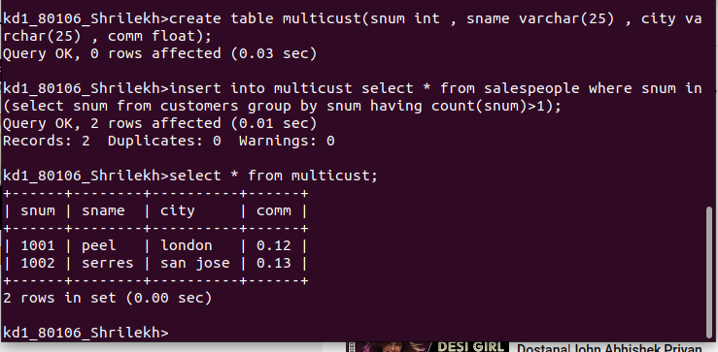

Q 2) Write a command that deletes all customers with no current orders.

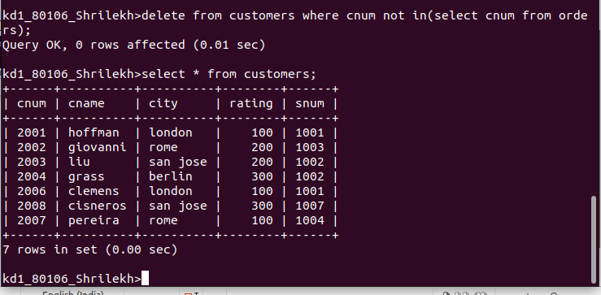

3)Write a command that increases by twenty percent the commission of all salespeople with orders above Rs:3000.

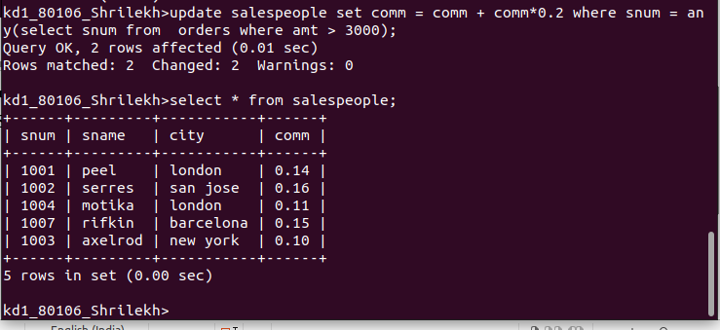
1

