ASSIGNEMENT 13

1) Create a union of two queries that shows the names,cities and ratings of all customers .Those with the rating greater than 200 or greater will also have the words “High rating” ,while the others will have the words “Low rating”.
Ans:

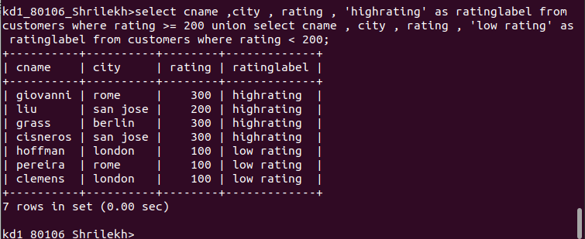

2)Write a command that produces the name and number of each salespeople and each customers with more than one current order.Put the results in alphabetical order.

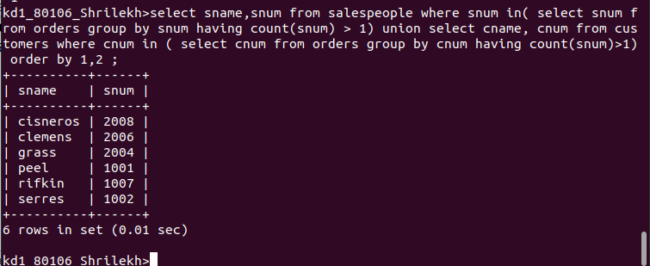
Q

3)Form a union of three queries.Have the first select the snums of all salespeople in San Jose;the second, the cnum of the customers in San jose and third the onums of all orders on october 3.Retain duplicats between last two queries but eliminate any redundancies between either of them.

