Assignment No.9

Q1) Write a query tha lists each order number followed by name of the customer who mde the order.
Ans:
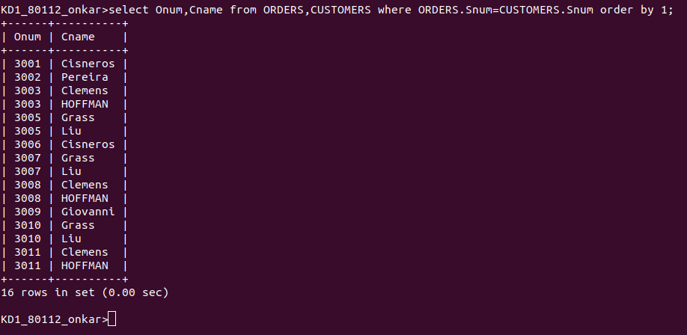

Q2) Write a query that gives the names of the both the salesperson and the customer for each order along with the order number.
Ans:
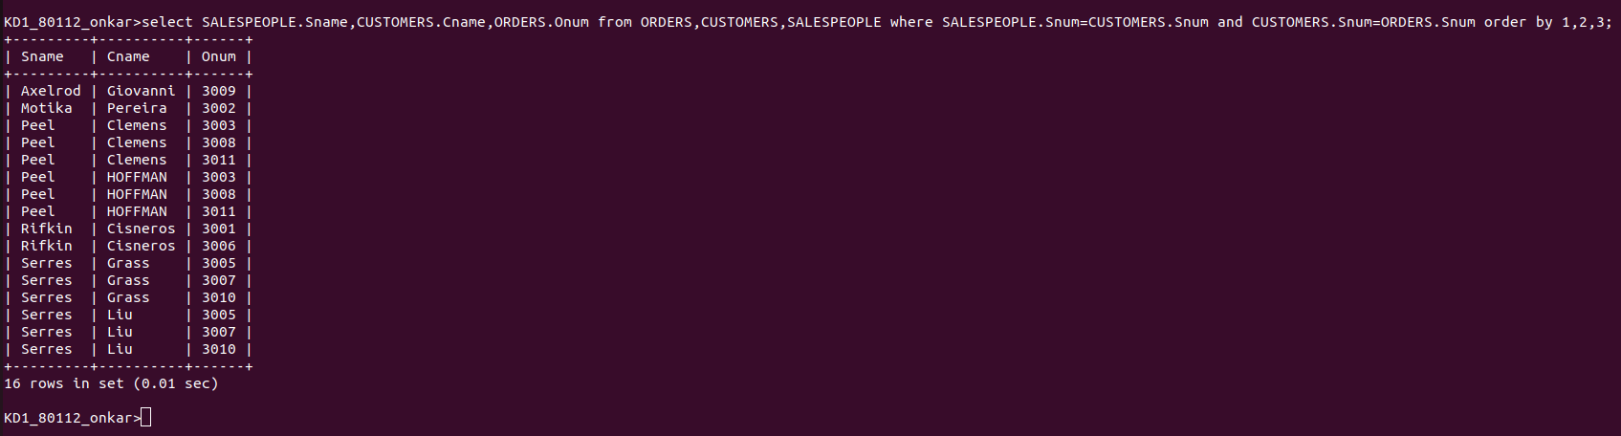

Q3) Write a query that produces all customers serviced by salespeople with a commission above 12%.output the customer’s name , the salesperson’s name, and the salesperson’s rate of commission.
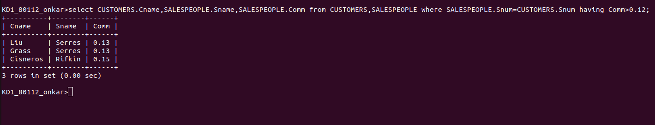
Ans:

Q4) write a query that calculates the amount of the salesperson’s comission
on each order by a customer with a rating above 100
Ans:
