1)Write a command that puts the following values, is their given order, into the salespeople table: city San Jose, name - Blanco, comm - NULL, cnum -1100.
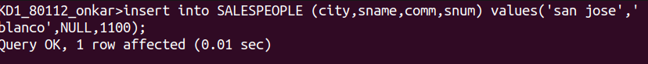
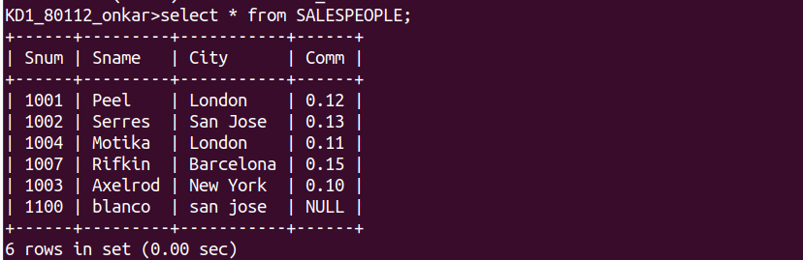
Ans

2) Write a command that removes all orders from customer Clemens from the Orders table.
Ans
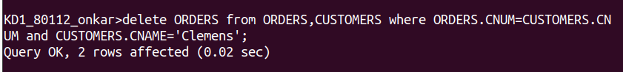
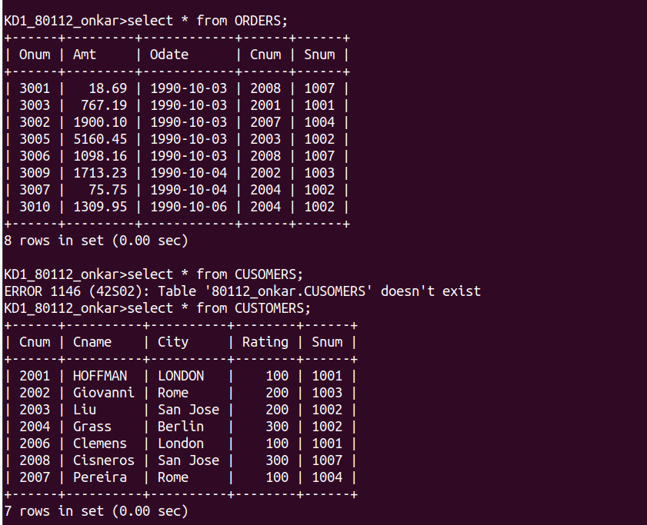

3) Write a command that increases the rating of all customers in Rome by 100.
Ans
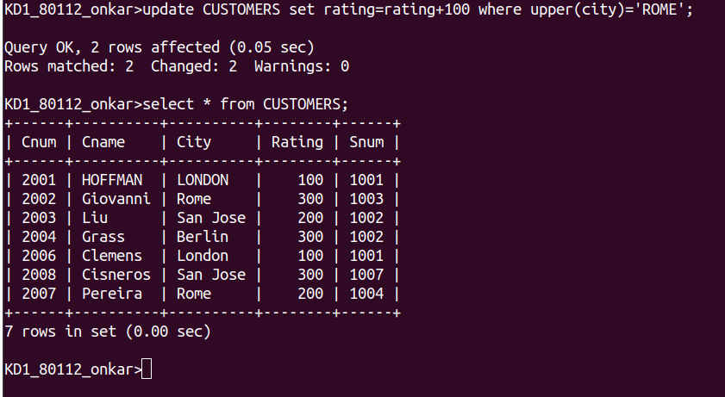

4) Salesperson Serres has left the company. Assign her customers to Motika.
