Assignment No.6

Q1)Write two different queries that would produce all orders taken o October 3rd or 4th ,1990.
Ans:
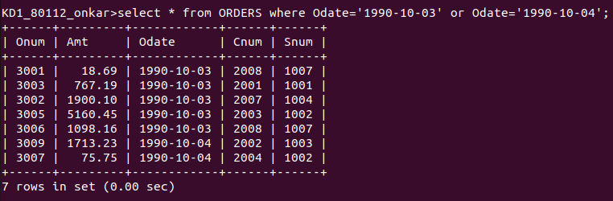
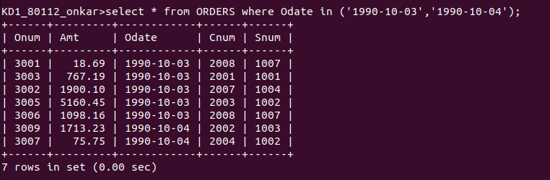

Q2) Write a query that selects all of the customers serviced by peel or motika.
Ans:
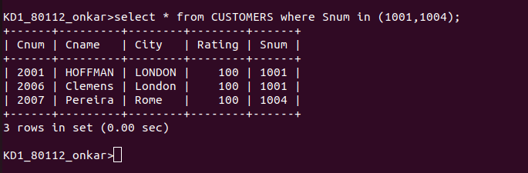

Q3) Write a query that will produce all the customers whose names begin with a letter from ‘A’ to ‘G’.
Ans:
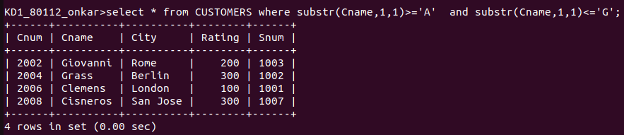
Q4) write a query that selects all customers whose names begin with he letter ‘c’.
Ans:

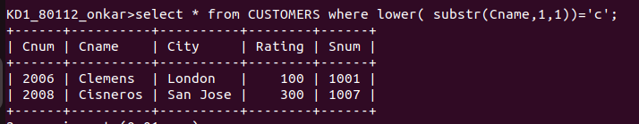
Q5) Write a query that selects all the orders except those with zeroes or NULLs in the amt field.
Ans:
