Assignment No.7

Q1)Write a query that counts all orders for october 3
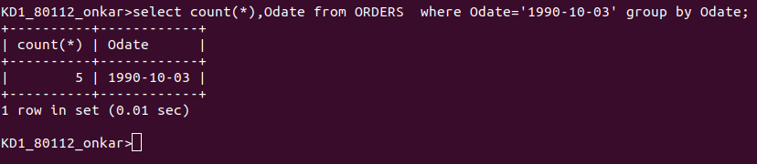
Ans:

Q2) Write a query that counts the number of different non-NULL city values in the Customers tables
Ans:

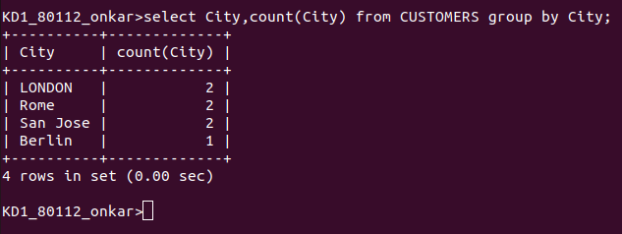
Q3) Write a query that selects each customer’s smallest order.
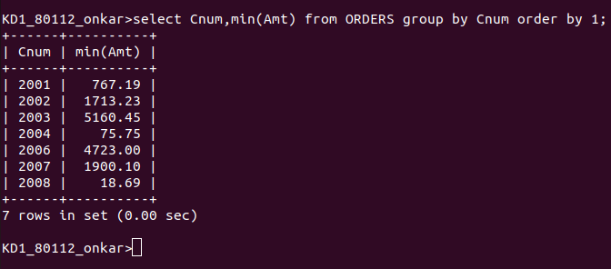
Ans:
Q4) Write a query that selects the highest rating in each city
Ans:
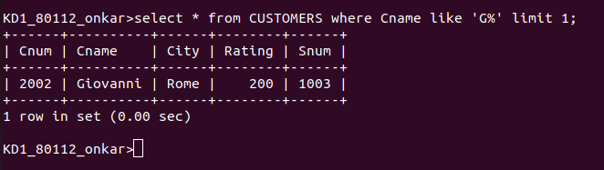
Q5) Write a query that selects the highest rating in each city
Ans:
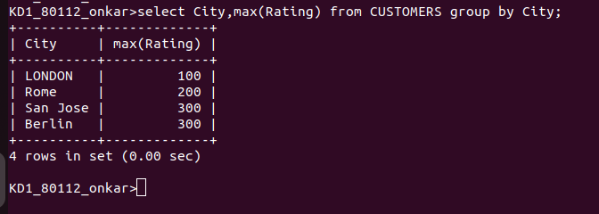
Q6) Write a query that counts the number of salespeople registering orders
for each day. If a salesperson has more than one order ona given day he or she should be counted only once
Ans:
