Assignment No.4

Q1) Wrie a select command that produces the order number,amount and date for all rows in the orders table.
ANS: Select Onum,Amt ,Odate from ORDERS;

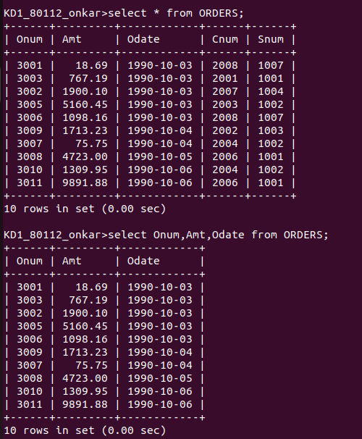

Q2) Write a query that produces all rows from the Customers table for which the salesperson number is 1001.
ANS: select * from CUSTOMERS where Snum=1000;
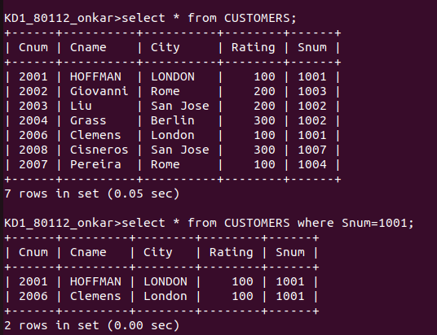

Q3) Write a query that displays the salespeople table with the columns in the following orders: city sname,sum ,comm.
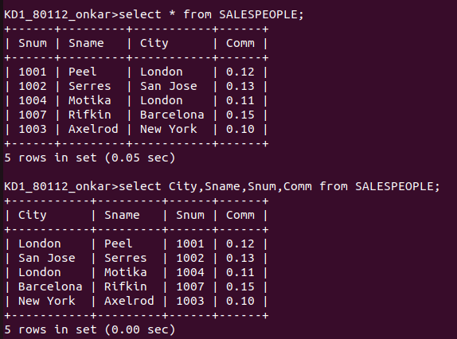
ANS: select City,Sname,Snum,Comm from SALESPEOPLE;

Q4) Write a select command that produces the ratings folloewd by the name of each customer in san jose
ANS: select Cname , Ratings from CUSTOMERS where City=’San jose’;
