Assignment 11

Q1) write a query that uses a subquery o obtain all orders for the customers named cisneros.assume you do not know his customer number (cnum)
Ans:
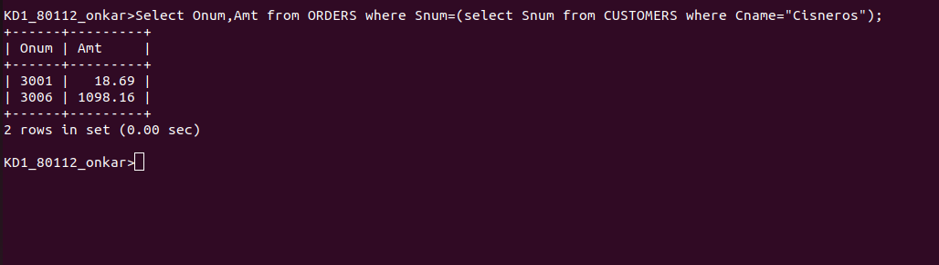
Q2) write a query that poduces the names and ratings of all customers who have above average orders
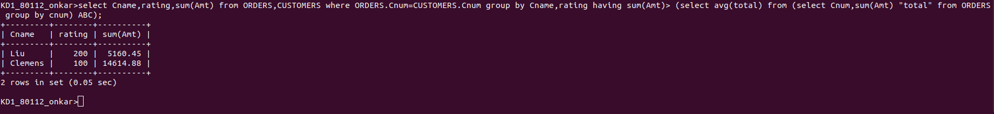
Ans:

Q3) write a query that selects the total amount in orders for each salesperson for whom this total is
greater tahn the amount of the total largest order in the table
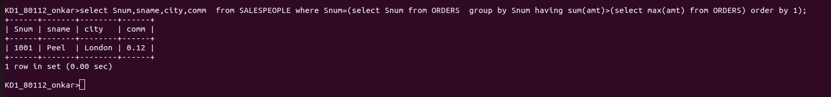
Ans:

