Assignment No.5

Q1) Write a query that will give you all orders for more than Rs.1000.
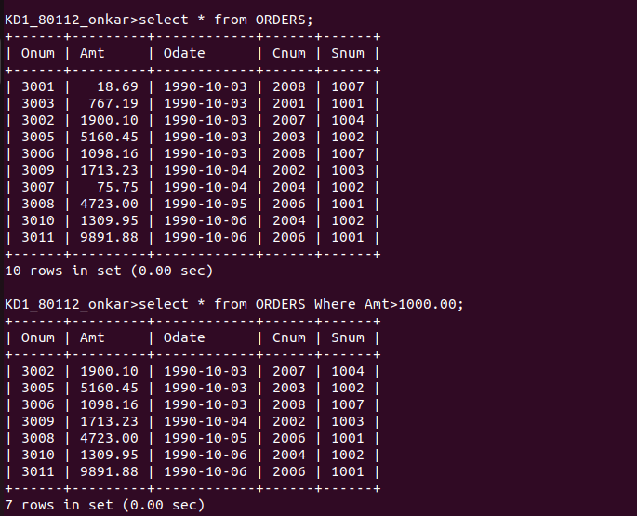
Ans:

Q2) Write a query that will give you the names and cities of all salespeople in London with a commision above .10.
Ans:
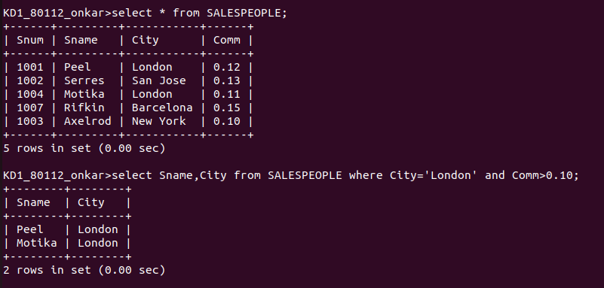
Q3) Write a query on the Customers table whose output will excludes all customers with rating <=100, unless they are located in Rome.
Ans:
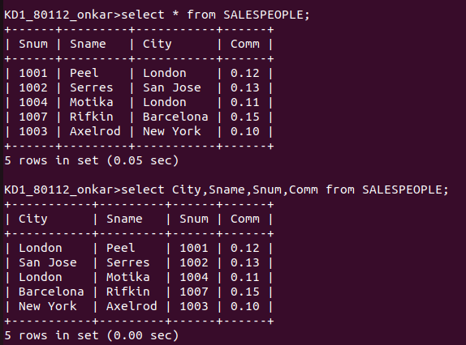

Q4) What will be the output from the following query,
select * from orders
where (amt<1000 OR NOT(odate=’1990-10-03’ AND cnum>2003));
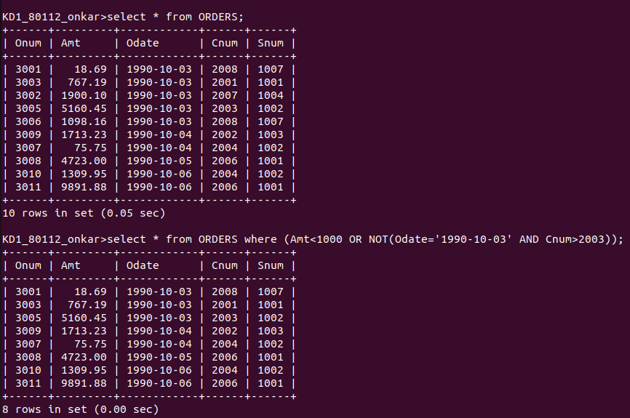
Ans:

Q5) What will be the output of the following query
select * from orders
where NOT ((odate=’1990-10-03’ OR snum >1006) AND amt>=1500);
Ans:
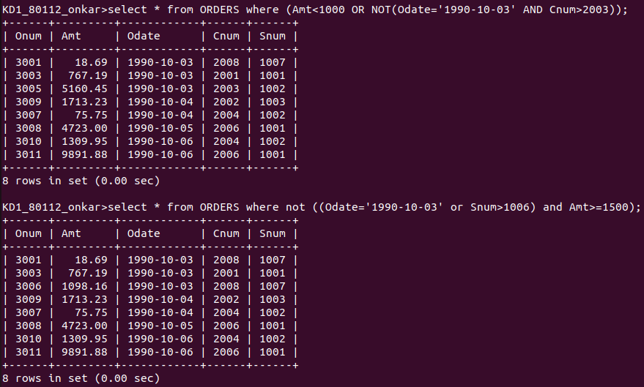

Q6) What is the simple way to write this query?
Select snum,sname,city,comm from salespeople where (comm>0.12 OR comm<0.14);
Ans:
