Assignment No.8

Q1) Assume each salesPerson has a 12% commision. Write a query on the orders table that will produce the order number, the salesperson number, and the amount of the salesperson’s commision for that order.
Ans:
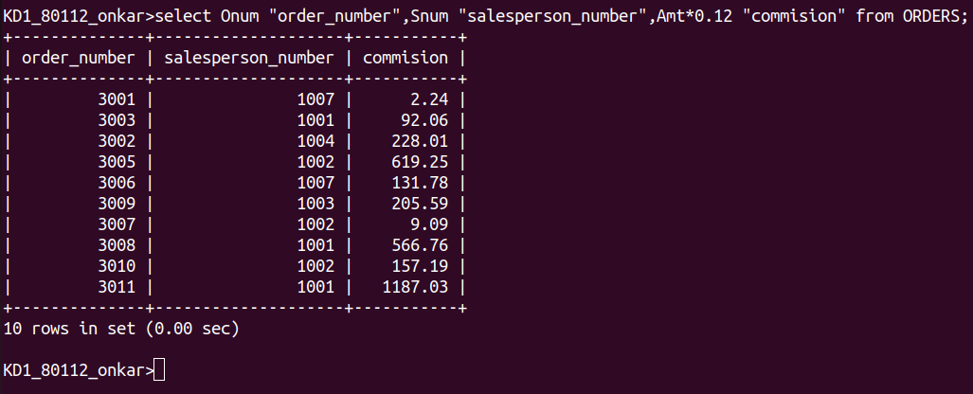
Q2) Write a query on the customers table that ill find the highest rating in city.Put the output in this form:
for the city (city) the highest rating is :(rating)
Ans:
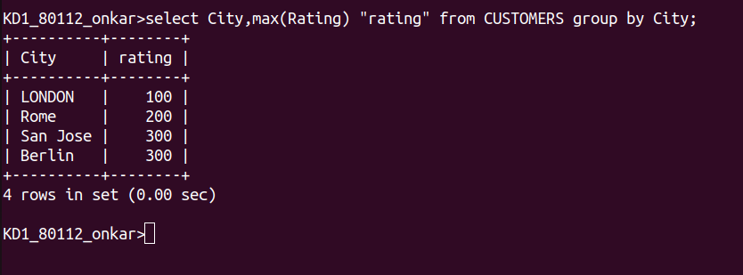

Q3) Write a query that lists customers in descending order of rating. Output the rating field first followed by the customers name and number.
Ans:
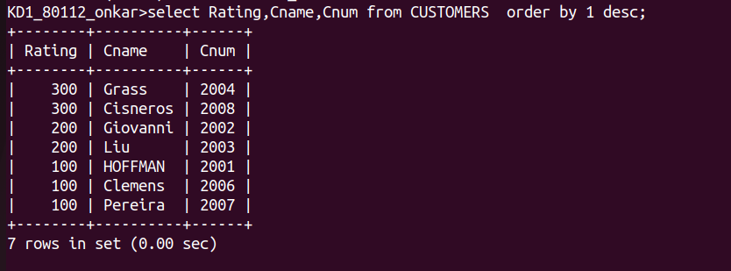
Q4) Write a query that totals the orders for each day and places the the results in
descending order.
Ans:
