ASSIGNMENT NO :- 02
1.
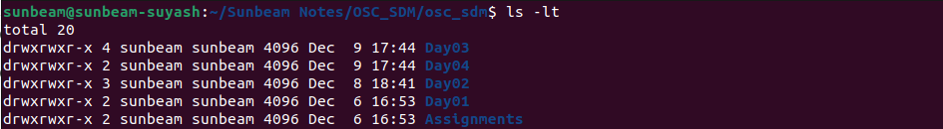
2.
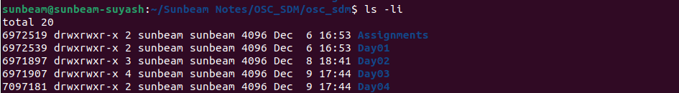
3.
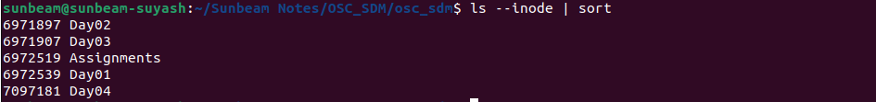
4.
5.
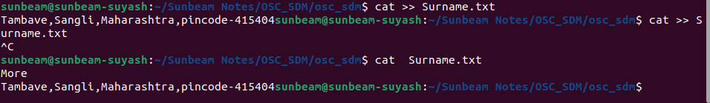
5.1&5.2

6.
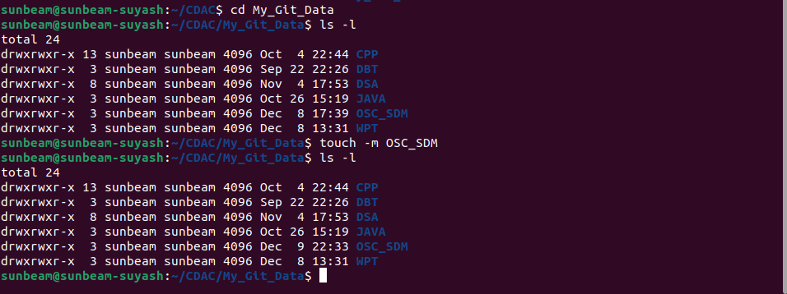

7.
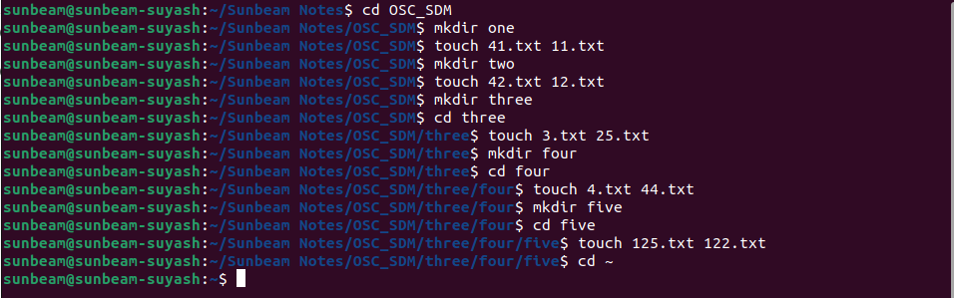
8.
8.1
8.2
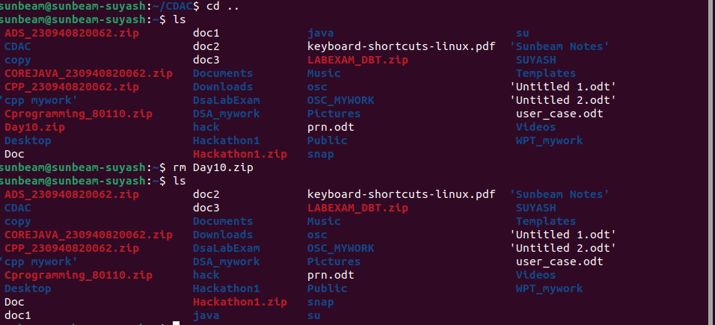
8.3
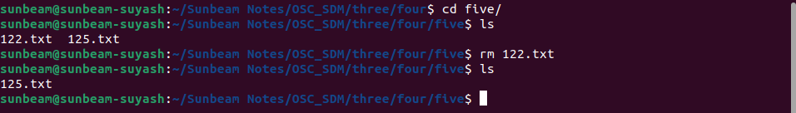
8.4
8.5

8.6
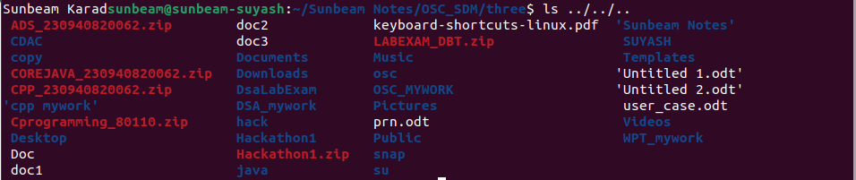
8.7
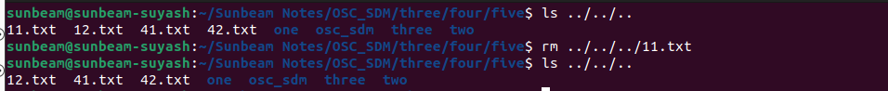
8.8

8.9
8.10
8.11
8.12
9.
