Q 1]:-

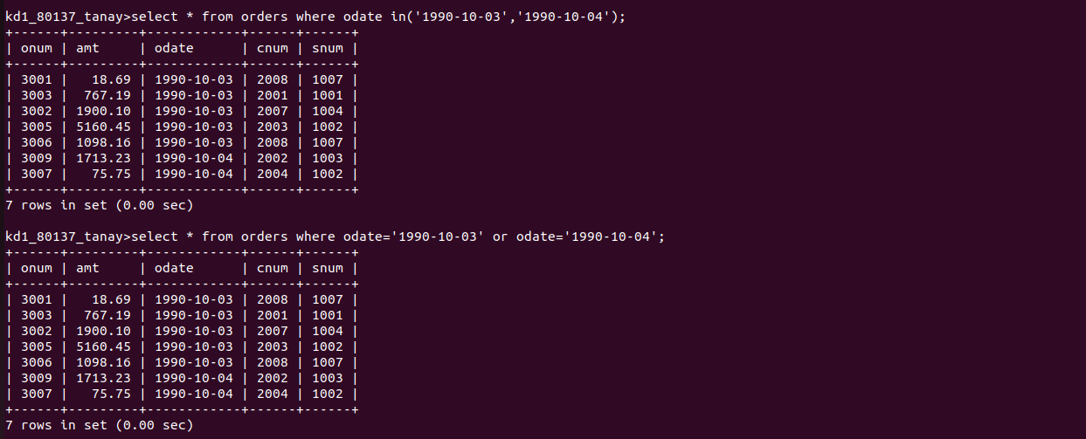

Q 2]:-

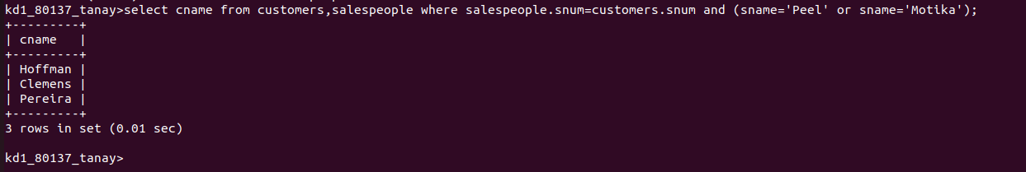

Q 3]:-

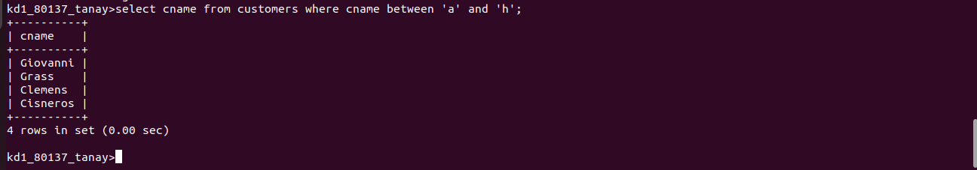

Q 4]:-
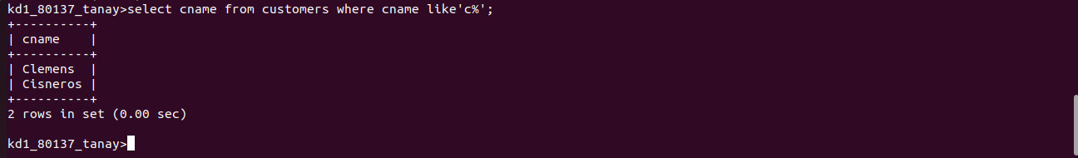

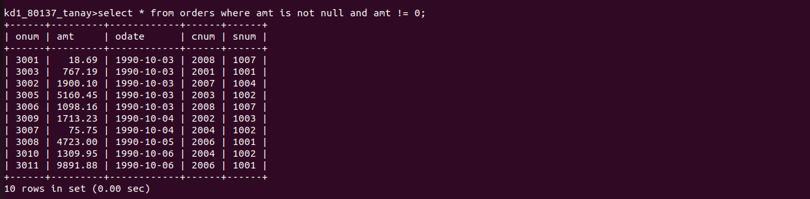
Q5]:-

