Q1] Creating sample tables and inserting values;-

A] Salespeople Table:-



B] CUSTOMER TABLE:-

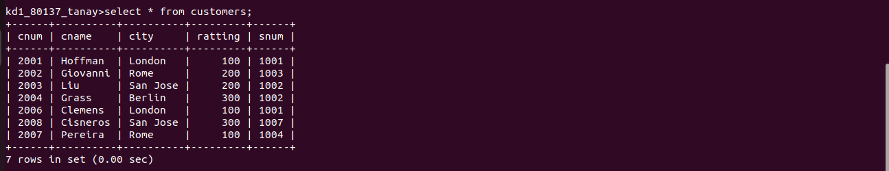

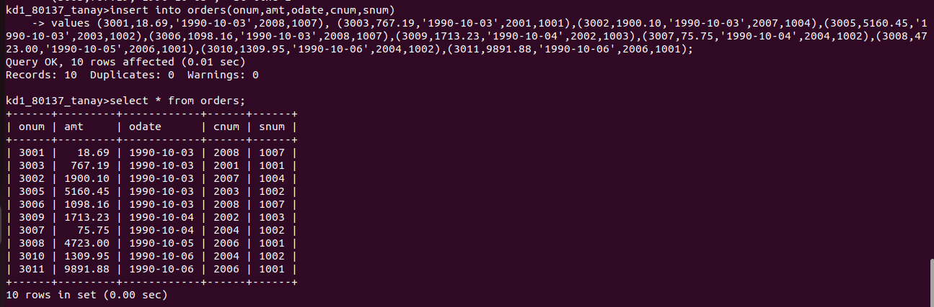
C] ORDERS Tables:-

