SQL_Assingment-14

Q.1--> Write a command that puts the following values, in their given order, into the salespeople table: city – San Jose, name – Blanco, comm – NULL, snum – 1100.

Ans -->
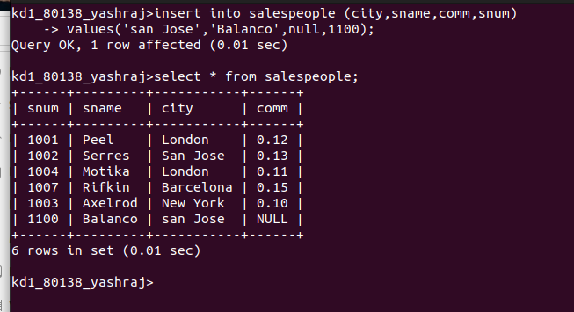

Q.2 -->Write a command that removes all orders from customer Clemens from the Orders table.

Ans -->
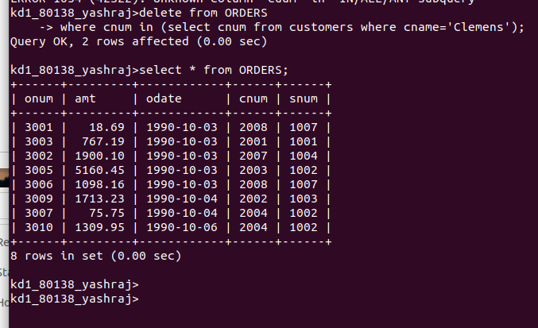

Q.3 --> Write a command that increases the rating of all customers in Rome by 100

Ans-->
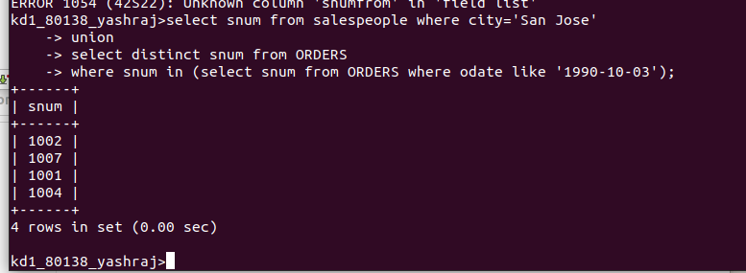

Q.4 --> Salesperson Serres has left the company. Assign her customers to Motika.

Ans -->
