Assignment no 1

Q1 – create salespeople,customers,orders table and insert data
-->
table of salespeople created
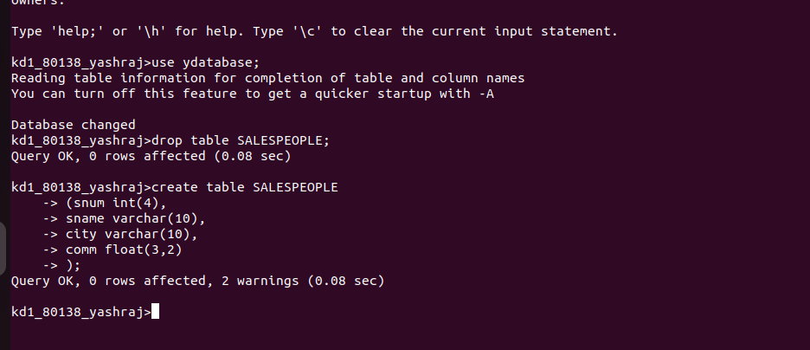

table of customers and orders created

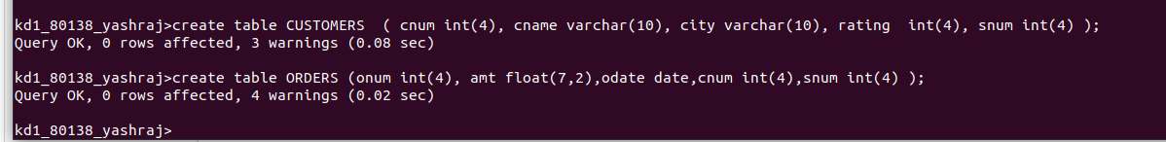

data in salespeople entered

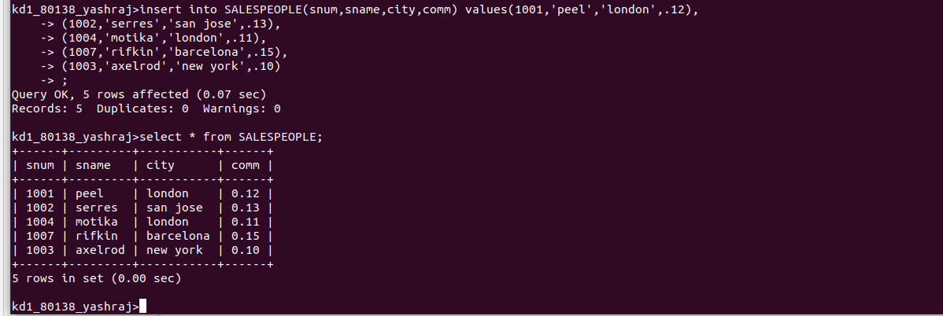

data in customers table entered

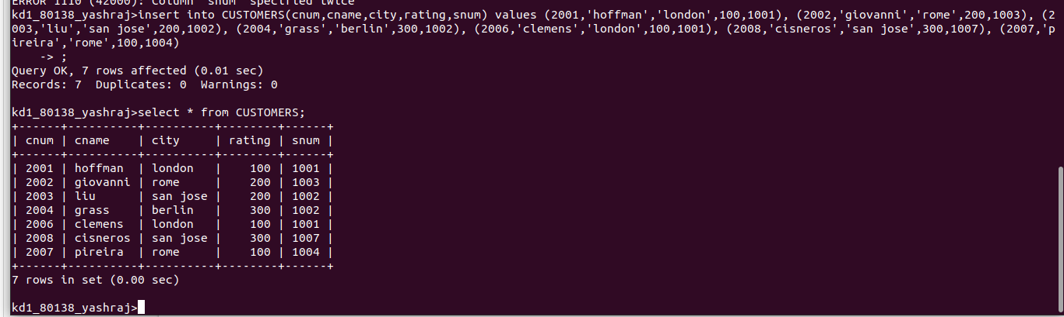

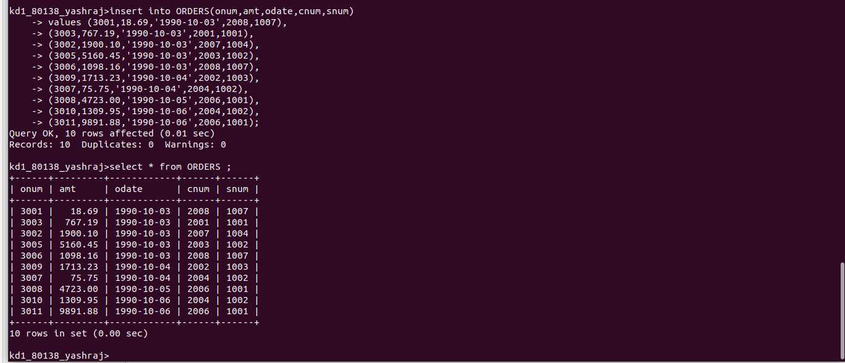

data in orders table entered

