Assignment 5
Q-1
Ans =

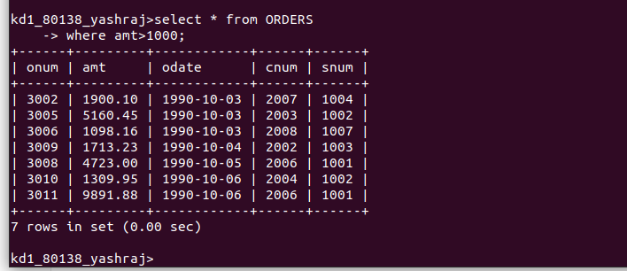
Q-2
Ans=


Q-3
Ans =


Q-4
Ans=
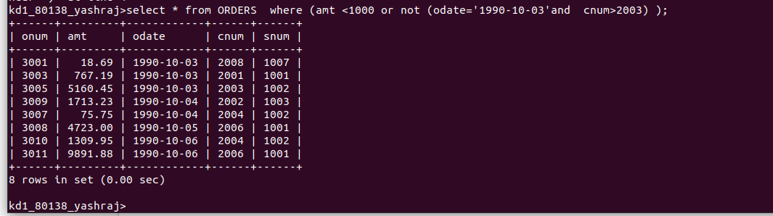

Q-5
Ans=


Q-6 What is the slimper way to write this Query?
Select snum , sname,city,comm from salespeople
where(comm>.12 or comm<.14);

Ans = select * from SALESPEOPLE;

