1. Query that selects all customers whose ratings are equal to or greater than Any of Serres.

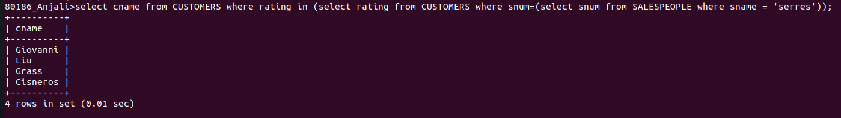
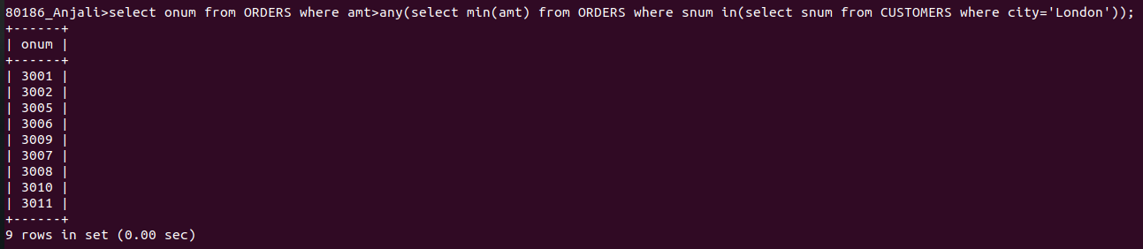
2. Query using ANY or ALL that will find all salespeople who have no customers located in their city.

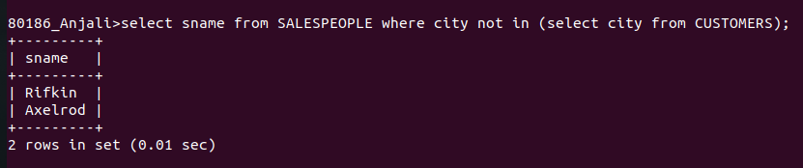
3. Query that selects all orders from amounts greater than any of the customers in London.
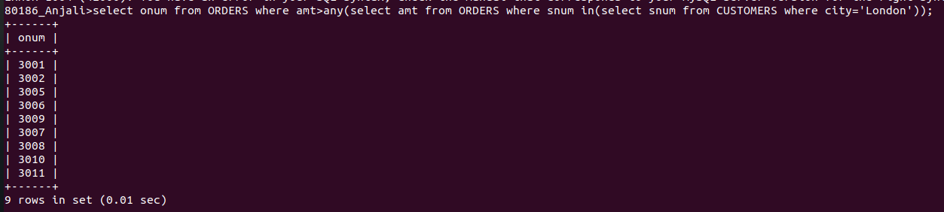
4. Above query using MIN or MAX.

