1. Query that uses subquery to obtain all orfers for the customers named Cisenors.

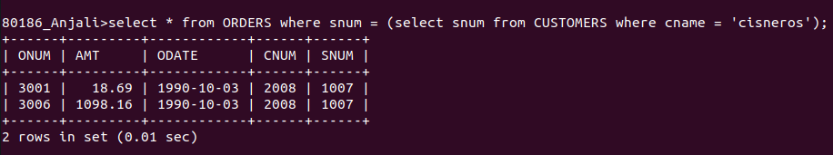
2. Query that produces the names and ratings of all customers who have above average orders.

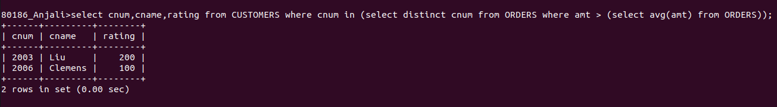

3. Query that selects the total amount in orders for each salesperson foe whom this total is greater than the amount of the largest order in the table.
