1. Write a query that will give all orders more than RS.1000.

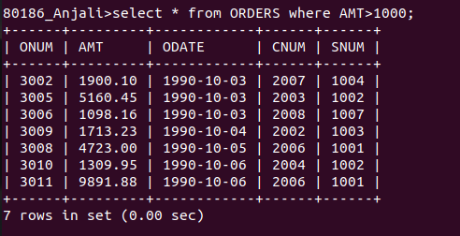

2. Write a query that will give the names and cities for all salespeople in London with commisision above .10
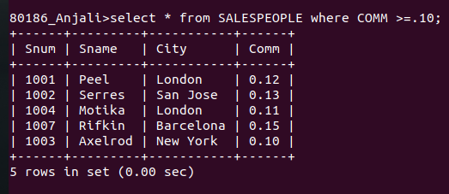

3. Write a query on the CUSTOMERS table whose output will execlude all cutomers with a rating <= 100, unless they all are located in Rome.

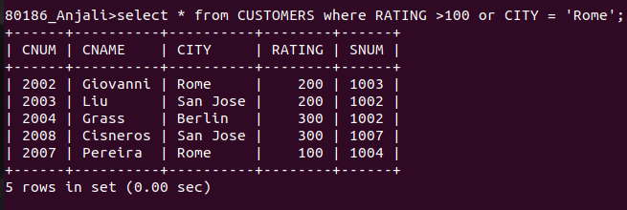

4. Output of following query

select * from ORDERS where (AMT <1000 or not (ODATE = '1990-10-03'and CNUM > 2003));

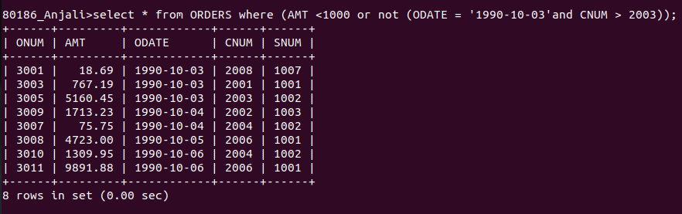

5. Output of following query

select * from ORDERS where not((ODATE = '1990-10-03' or SNUM > 1006) and AMT>=1500);

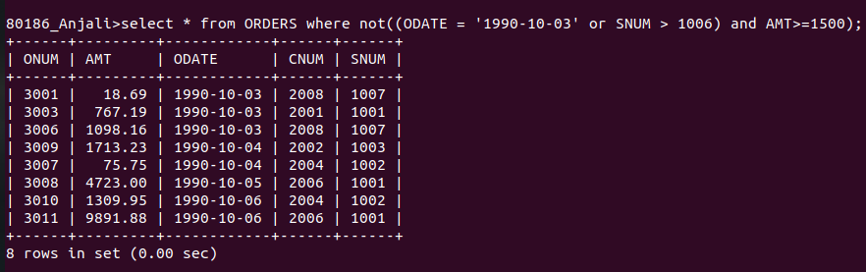

6. simplest way to write following query

select snum,sname,city,comm from salespeople where (comm>.12 or comm<.14);

Ans:
select SNUM, SNAME,CITY,COMM from SALESPEOPLE where COMM BETWEEN 0.13 and 0.14

