1. Query that lists each order number followed by the name of the customers who made this order.

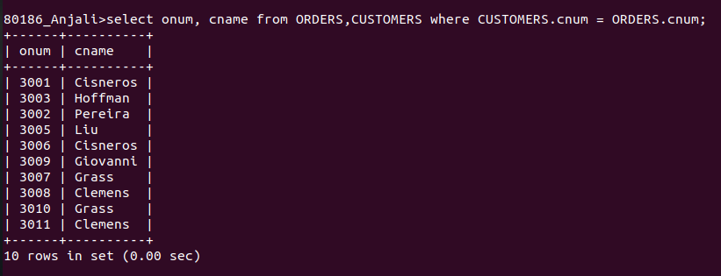

2. Query that gives the names of both the salesperson and the customer for each order along with the order number.
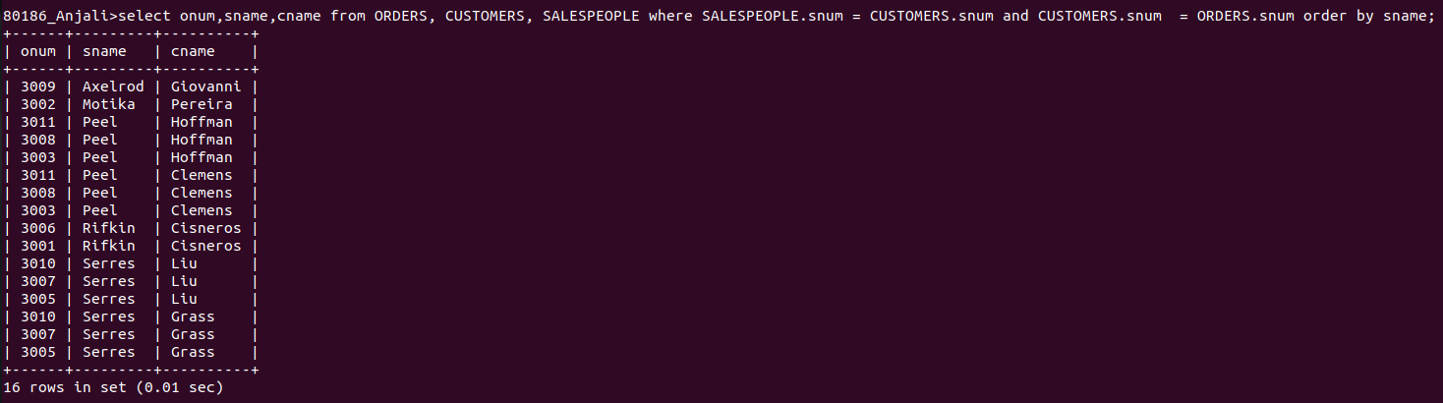

3. Query that produces all customers servised by salespeople with a commision above 12%.

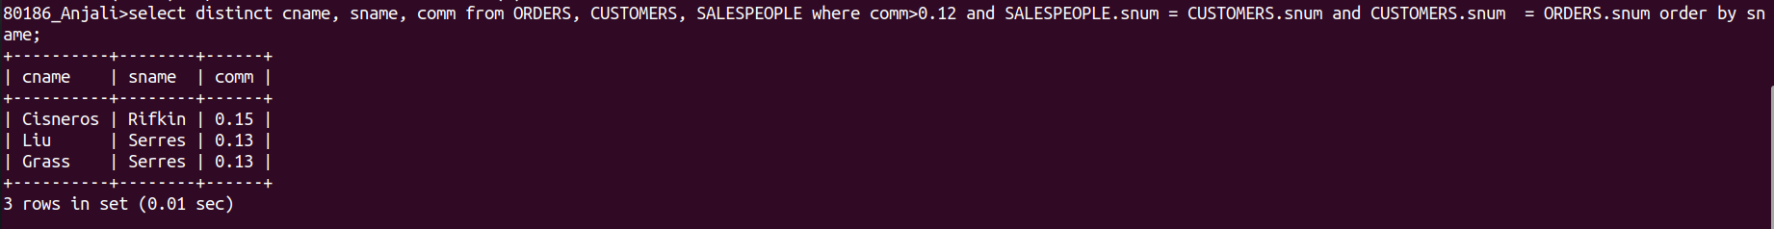

4. Query that calculates the amount of salespeoples commision on each order by a customer with a rating above 100.

