ASSIGNMENT NO :13
PRN : 80186

1. create a union of two queries that shows the names cities and ratings of all customers those with rating of 200 are greater will also have the words high rating while others will have the words low rating.

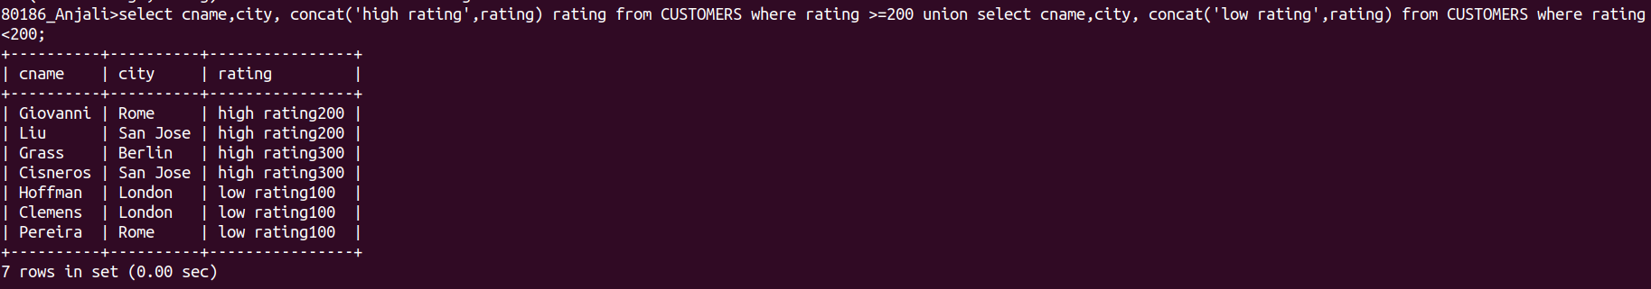

2. write a command that produces the name and number of each persons person and each customer with more than one current order put the result in alphabetical order.
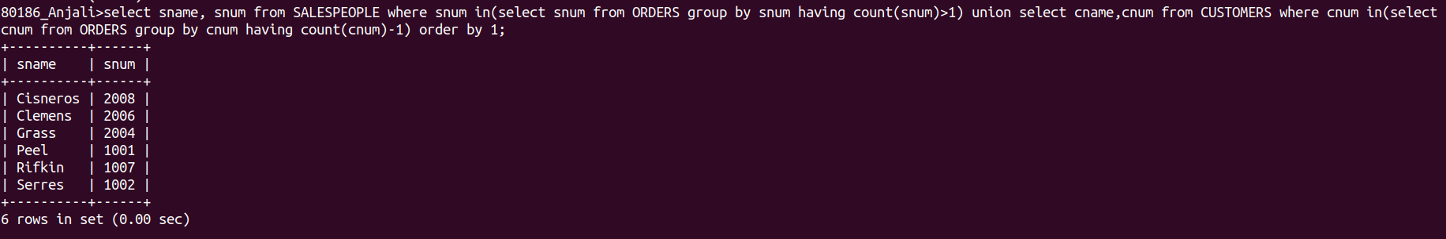

3. form a union of three queries. Have the first select the snum of all sales people in San Jose; the second, the Cnum of all customers in San Jose and the third the onums of all orders customers in October 3 1990 Retain duplicates between the last two queries but eliminate any redundancies between either of them and the first.

