1. Write a SELECT command that produces the order number, amount and date for all rows in the ORDERS table.

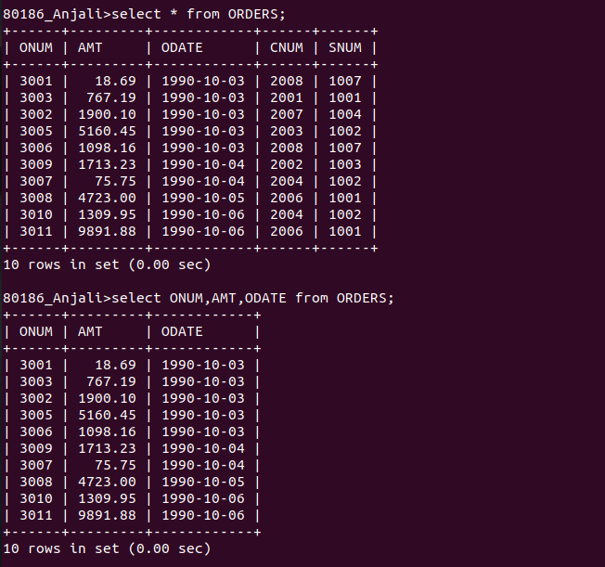
2. Write a query that prduces all rows from the CUSTOMERS table for which salespersons number is 1001
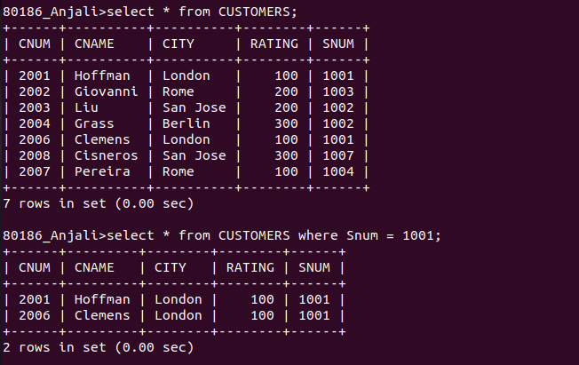

3. Write a query that displys the SALESPEOPLE table with the columns in the following order:
city, sname, snum, comm.
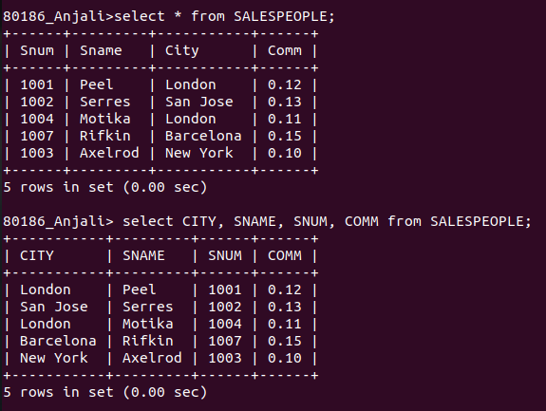

4. Write a SELECT command that produces the rating followed by the name of each customer in San Jose.

