Centre adjustment:

80186_Anjali>select concat(lpad(substr(ename,1,3),40,' '), rpad(substr(ename,4,6),40,' ')) from EMP_NAMES;

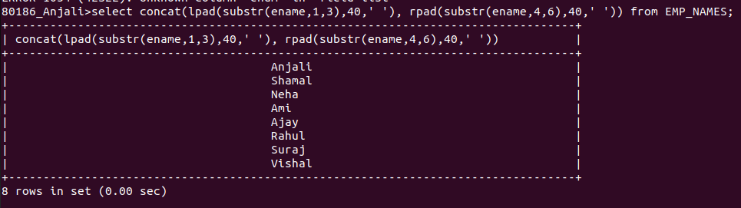
80186_Anjali>select upper(substr(ename,1,1)) from EMP_NAMES;
