1. Count all orders for oct 3

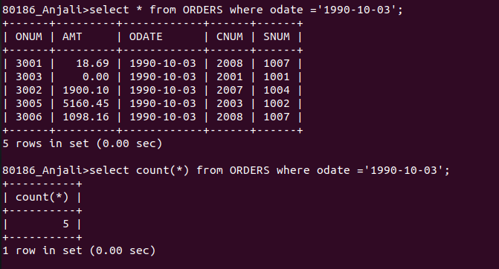

2.Count the number of different non null ciity values in the Customers table

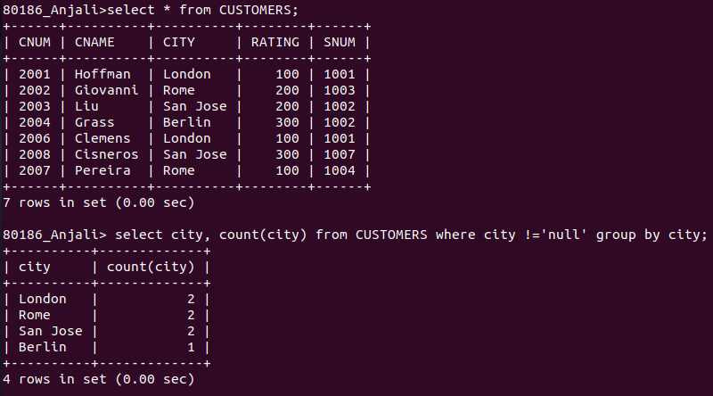

3. Each customers smallest order

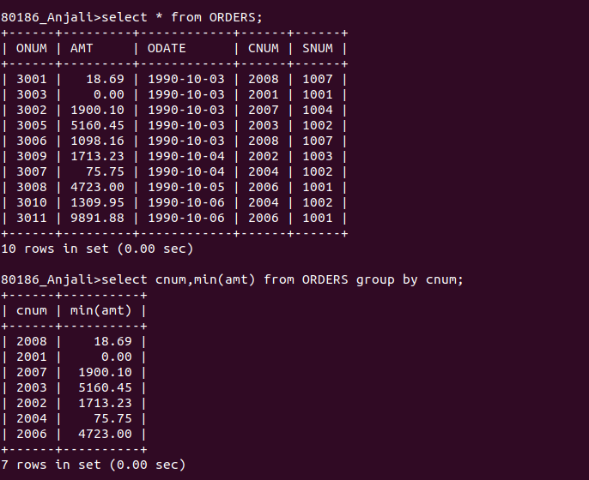

4. Select the first customer in aplhabetical order whose name begins with G.
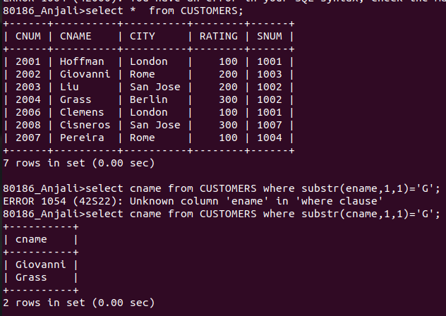

5. Select the highest rating in each city.
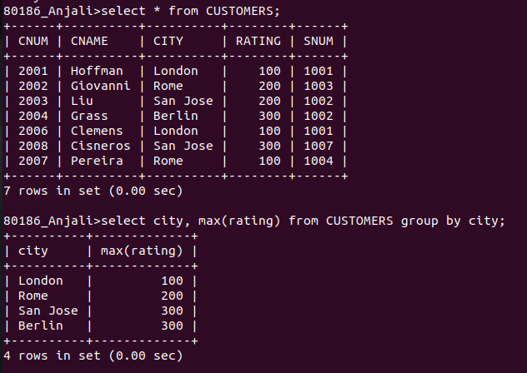
.

6. Count the number of salespeople registering order for each day( If a salesperson has more than one order on a given day he or she should be counted only once)

