ASSIGNMENT NO : 15
PRN : 80186
1. Assume there is a table called multicust with all of the same column definitions as salespeople. write a command that inserts all sales people with more than one customer into this table.
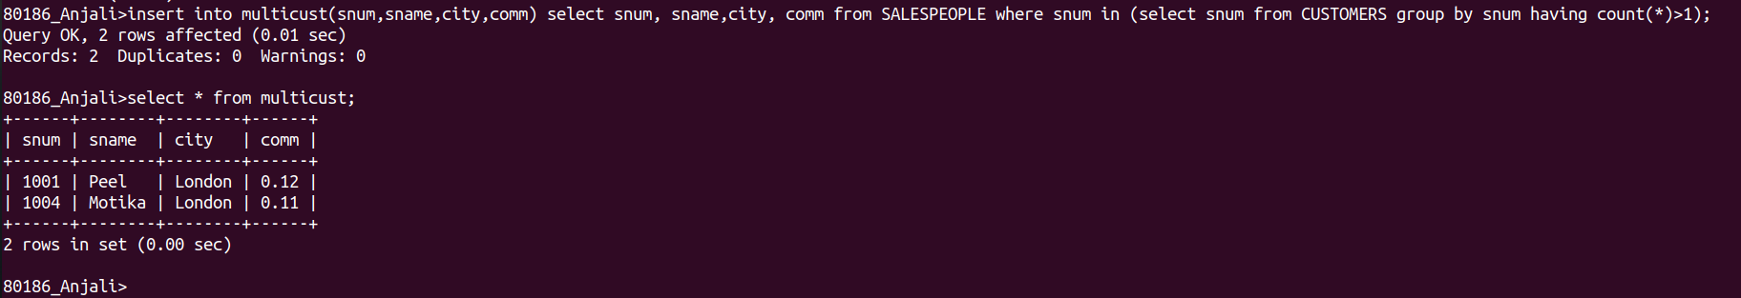

2. write a command that delete all customer with no current orders.

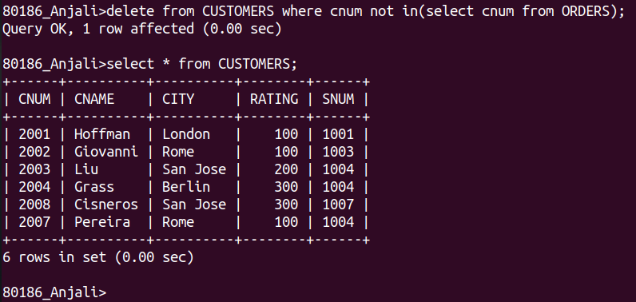

3. write a command that increases by 20% the commission of all salespeople with a total order above Rs 3000.

