1.Query that would produce all orders taken on October 3 or 4, 1990.

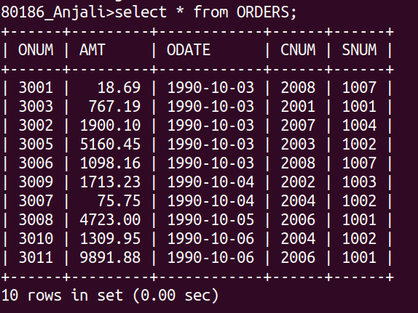
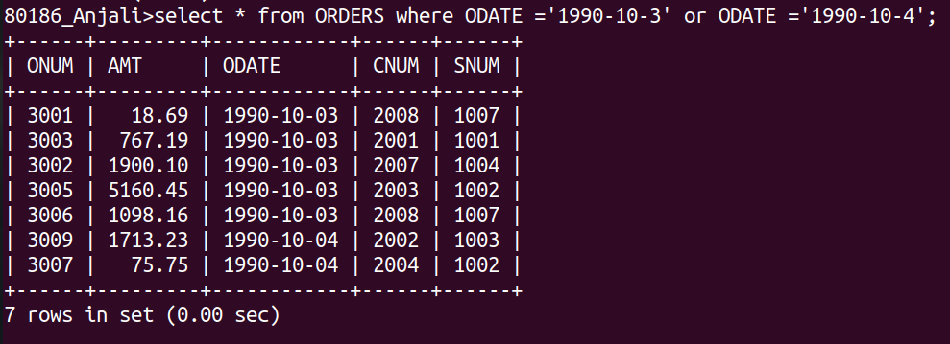

2. Query that selects all of the customers serviced by Peel or Motika.

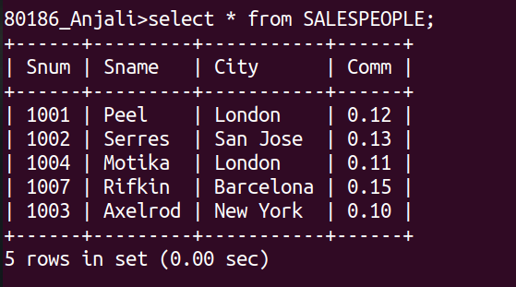
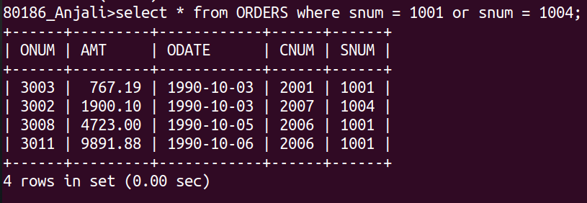

3. Query that will produce all the customers whose name begins with letter from ‘A’ to ‘G’.

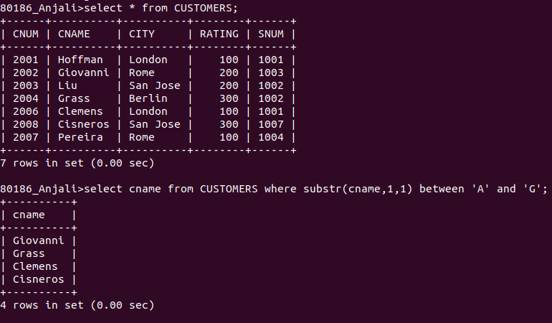

4. Query that will select all customers whose name begins with ‘C’.
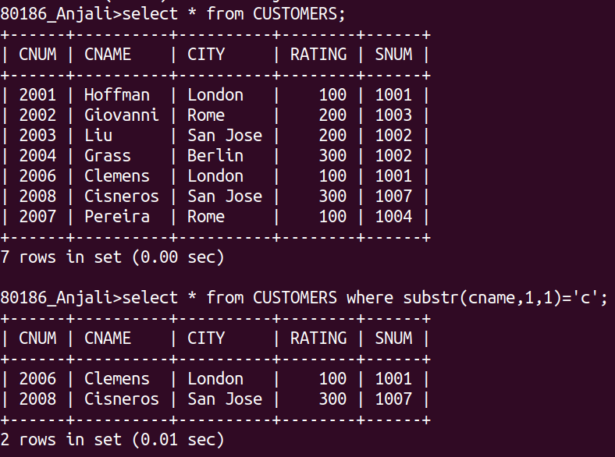
5. Query that selects all orders except those with zeros or nulls in the amt field.

