Creating sample tables and inserting values
Create tables with given structures and insert sample data.

QUESTION 1

create table SALESPEOPLE(Snum int(4), Sname varchar(10), City varchar(10), Comm float(3,2));

insert into SALESPEOPLE values
(1001, 'Peel', 'London', .12),
(1002, 'Serres', 'San Jose', .13),
(1004, 'Motika', 'London', .11),
(1007, 'Rifkin', 'Barcelona', .15),
(1003, 'Axelrod', 'New York', .10);

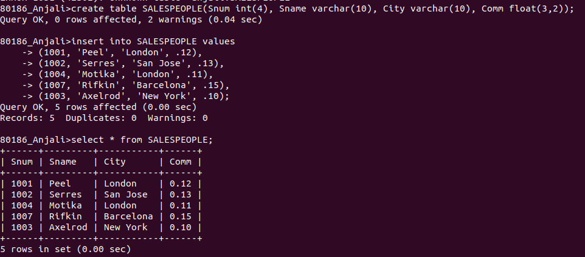

QUESTION2

create table CUSTOMERS (CNUM int(4), CNAME varchar(10), CITY varchar(10), RATING int(4), SNUM int(4));

insert into CUSTOMERS values
(2001,'Hoffman', 'London', 100, 1001),
(2002,'Giovanni', 'Rome', 200, 1003),
(2003,'Liu', 'San Jose', 200, 1002),
(2004,'Grass', 'Berlin', 300, 1002),
(2006,'Clemens', 'London', 100, 1001),
(2008,'Cisneros', 'San Jose', 300, 1007),
(2007,'Pereira', 'Rome', 100, 1004);

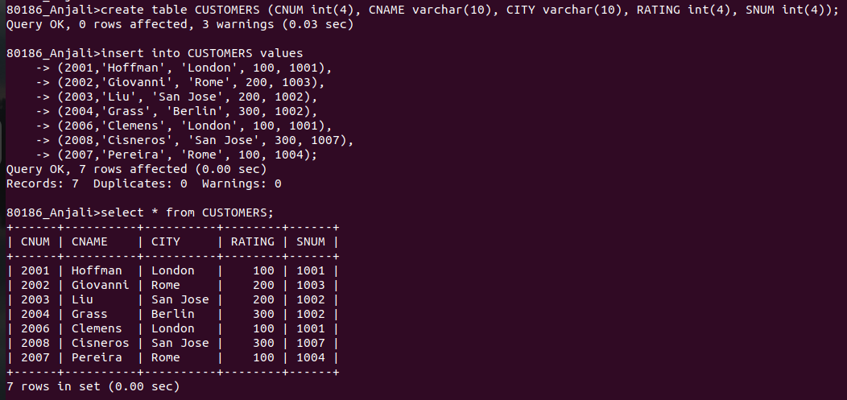

QUESTION3

create table ORDERS(ONUM int(4), AMT float(7,2), ODATE date ,CNUM int(4), SNUM int(4));

insert into ORDERS values
(3001, 18.69, "1990-10-03", 2008, 1007),
(3003, 767.19, "1990-10-03", 2001, 1001),
(3002, 1900.10, "1990-10-03", 2007, 1004),
(3005, 5160.45, "1990-10-03", 2003, 1002),
(3006, 1098.16, "1990-10-03", 2008, 1007),
(3009, 1713.23, "1990-10-04", 2002, 1003),
(3007, 75.75, "1990-10-04", 2004, 1002),
(3008, 4723.00, "1990-10-05", 2006, 1001),
(3010, 1309.95, "1990-10-06", 2004, 1002),
(3011, 9891.88, "1990-10-06", 2006, 1001);

