1. Query on ORDERS table that will produce the order number, the salesperson number abd the amount of the salesperosons commision for that order.

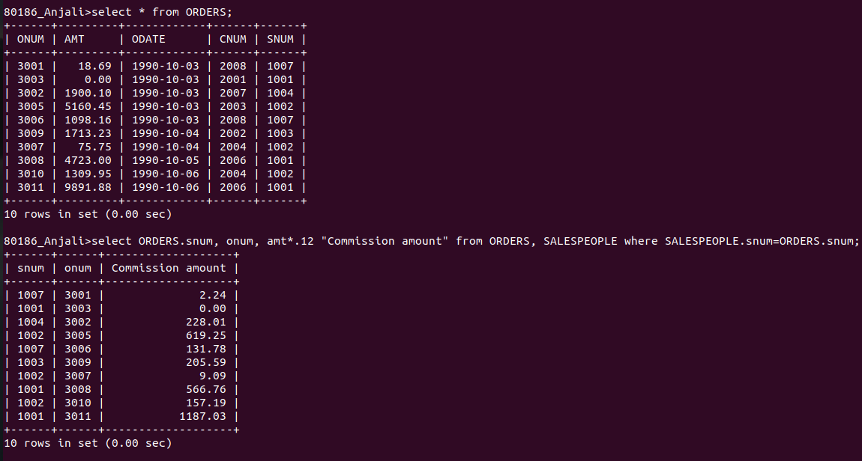

2. Query on CUSTOMERS table that will find the highest rating int the city.

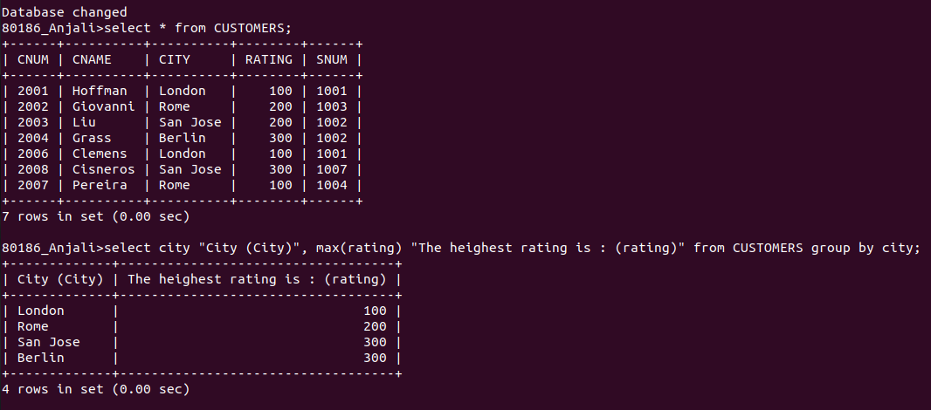

3. Query that lists customers in the decending order of rating.
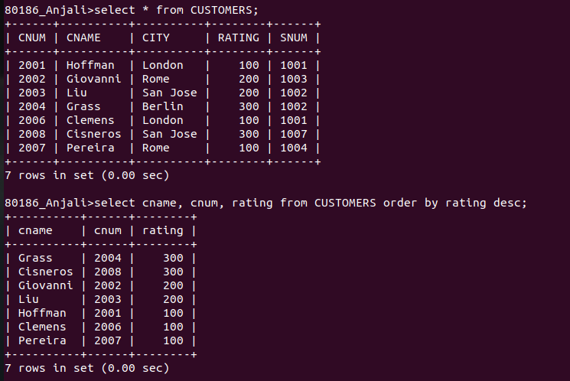

4. Query that totals the orders for each day and places that results in decending order.

