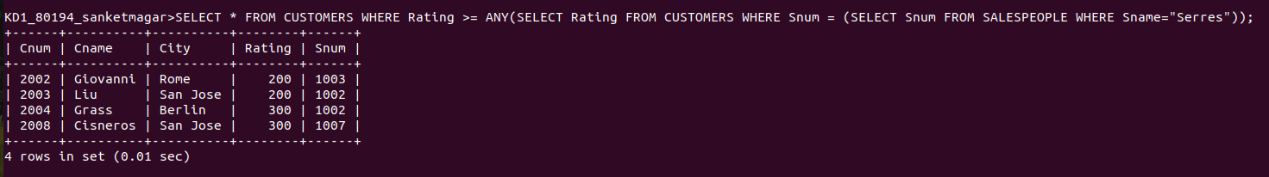
SQLAssignment 12
1) Write a query that selects all customers whose ratings are equal to or greater than ANY of Serres.
Ans:-

2) Write a query using ANY or ALL that will find all salespeople who have no customers located in their city.
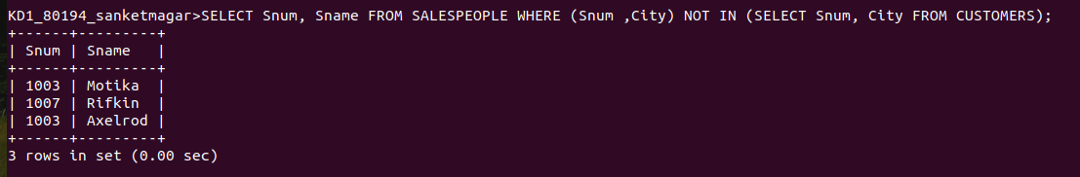
Ans:-
3) Write a query that selects all orders for amounts greater than any for the customers in London.
Ans:-

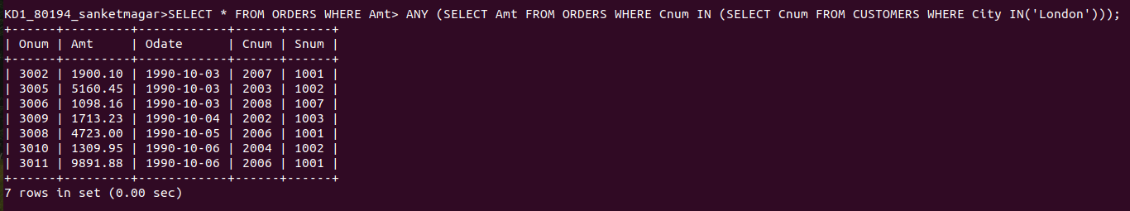
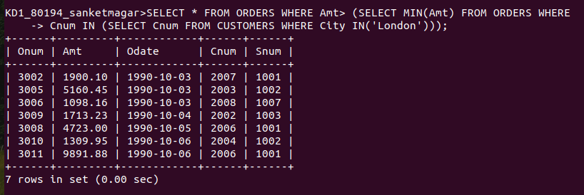
4) Write the above query using MIN or MAX.
Ans:-

