Assignment-7

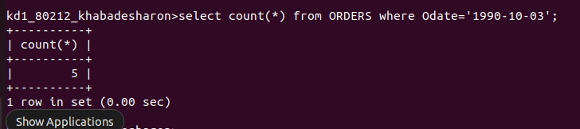
1. Write a query that counts all orders for October 3.

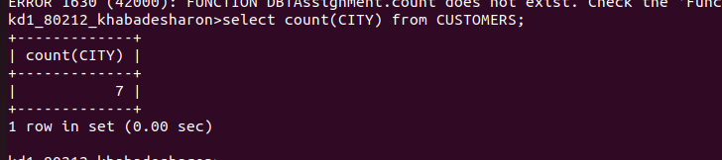
2. Write a query that counts the number of different non-NULL city values in the Customers table.

3. Write a query that selects each customer’s smallest order.

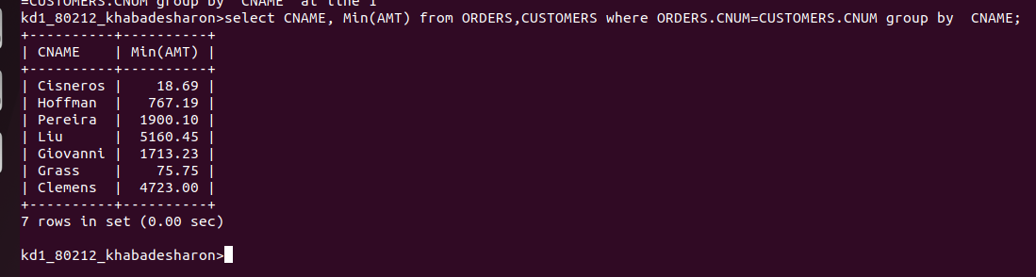

4. Write a query that selects the first customer,in alphabetical order, whose name begins with G.


5. Write a query that selects the highest rating in each city.

6. Write a query that counts the number of salespeople registering orders for each day. (If a salesperson has more than one order on a givingday, he or she should be counted only once.)

