ASSIGNMENT- 5
Q1) Write a query that will give you all orders for more than RS .1000.
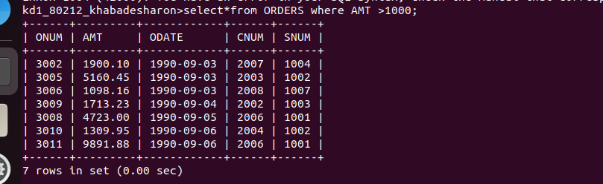
Ans:

Q2)Write a query that will give you thae name and cities of all salespeople in london with commision above 0.10?
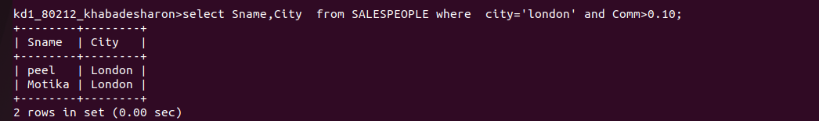
Ans:

Q3.write query on customer table whose output will exclude all customer with a rating <=100,unless they are loacted in rome?
Ans
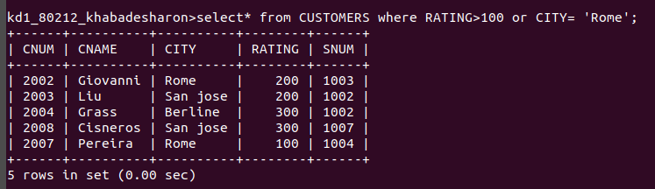

O4.what will be the output rom the following query :
select * from orders
where(amt<1000 or not (odate = '1990-10-03' and cnum>2003));
Ans
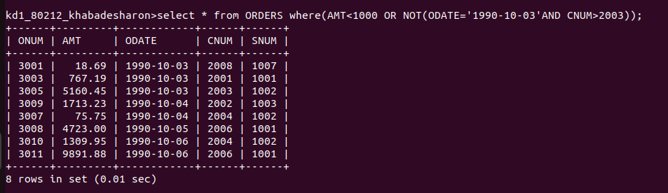

Q5what will be the output from the following query :
select * from orders
where not ((odate = '1990-10-03' or sum>1006) and amt
>=1500));
Ans;

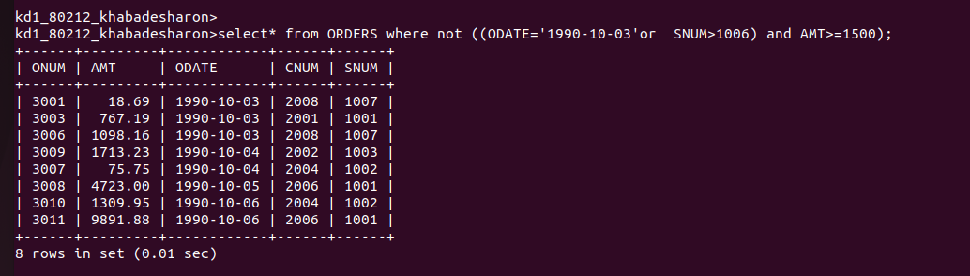

Q6what will be a simpler way to write this query/
select snum,sname,city,comm from salespeopple where (comm.0.12 or comm,0.14)?
Ans
